**2022 -2023**

**Hartsfield Animal & Environmental Sciences Magnet**

**Faculty Handbook**

**5001 Perry Street, Houston, Texas 77021**

**Office: (713)746-8280 /Fax: (713)746-8283**

**Table of Contents**

|  |  |  |
| --- | --- | --- |
| Mission, Vision, & Goals Statement |  | 4 |
| **SECTION I – PROFILE OF EXCELLENCE** |  | 5 |
| Data at a Glance |  | 6-10 |
| From the Principal’s Pen |  | 11 |
| Hartsfield @ the CORE |  | 12 |
| Profile of Scholar |  | 13 |
| Instructional Non-Negotiable |  | 14-15 |
| Shared Leadership Responsibilities |  | 16-19 |
| Behavior Expectations |  | 19-21 |
| Campus-wide Behavioral Expectations |  | 21-23 |
| Student Discipline & Behavior |  | 23-25 |
| Conduct and Consequence Chart |  | 25-26 |
| Student Dress Code |  | 26-27 |
| **SECTION II – REASON FOR NONRENEWAL** |  | 28 |
| Contract Policy |  | 29-33 |
| **SECTION III – EXCELLENCE ARTICULATED** |  | 34 |
| Operational Procedures |  | 35-38 |
| Field Experiences |  | 39 |
| Communication |  | 40 |
| Professionalism |  | 41-42 |
| Student Attendance |  | 43-45 |
| Lunch and Restrooms |  | 46-47 |
| Clinic Procedures |  | 47 |
| Textbook & Library Books |  | 48-49 |
| Instructional Information |  | 49-55 |
| General Information |  | 55-56 |
| Schedules and Calendars |  | 57-58 |
| Technology & Computer |  | 58-64 |
| Student Arrival and Dismissal |  | 65 |
| Emergency Procedures |  | 66-72 |
| General Safety & Security Procedures |  | 72-74 |
| **SECTION IV – FORMS & DOCUMENTS** |  | 75 |
| Employee Warning Notice |  | 76 |
| Time Off Request |  | 77 |
| Absence From Duty |  | 78 |
| Materials Request |  | 79 |
| Field Trip Request |  | 80 |
| Fundraising Request |  | 81 |
| Committee Meeting/Ad Hoc |  | 82 |
| Intervention Assistance Team (IAT) |  | 83 |
| Monthly Calendar Events Submission |  | 84 |
| Parent Contact Log |  | 85 |
| Maintenance Request |  | 86 |
| Room Reservation Request |  | 87 |
| Receipt of Teacher Handbook |  | 88 |
|  |  |  |
|  |  |  |
|  |  |  |
|  |  |  |
|  |  |  |
|  |  |  |

**Mission and Vision Statement**

**MISSION:**

Hartsfield Animal & Environmental Sciences Magnet builds a college preparatory foundation for all scholars through strong academics, dedicated teachers, purposeful actions, and ethical character.

**VISION:**

Hartsfield Animal & Environmental Sciences Magnet will expand educational opportunities in ways that are life-changing for children and transformational for our community.

**PROFILE**

**OF**

**EXCELLENCE**

**DATA AT A GLANCE**

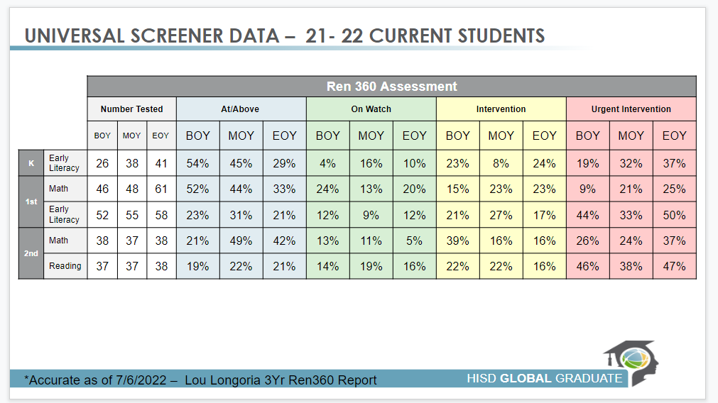

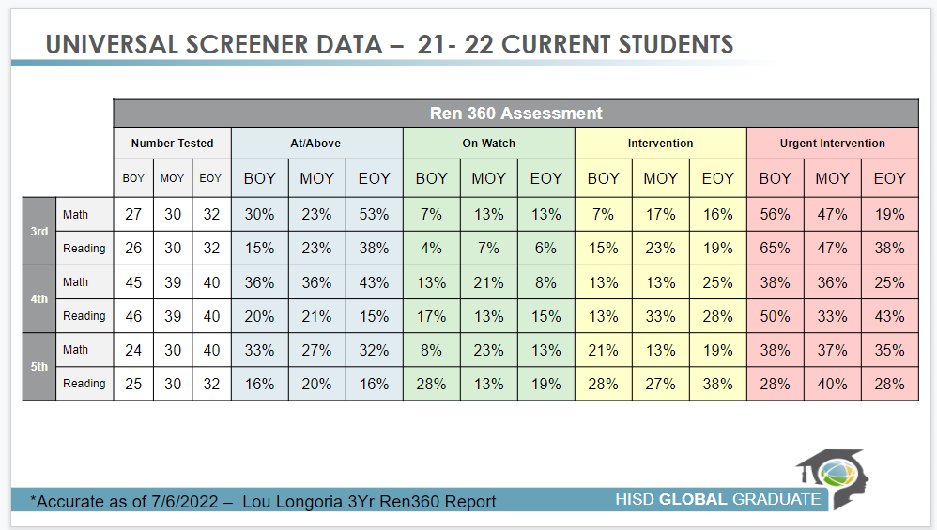

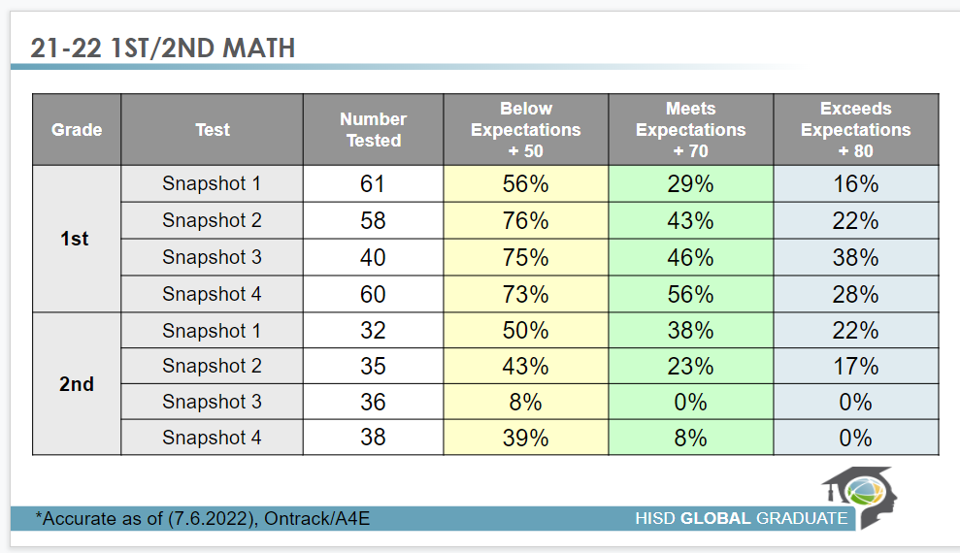

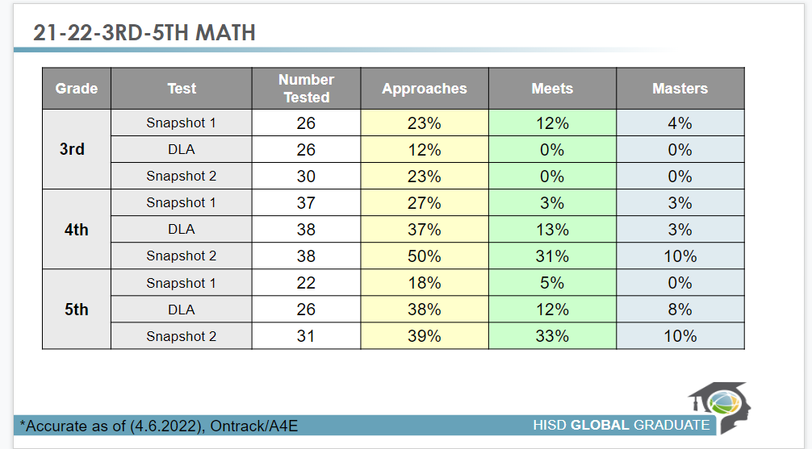

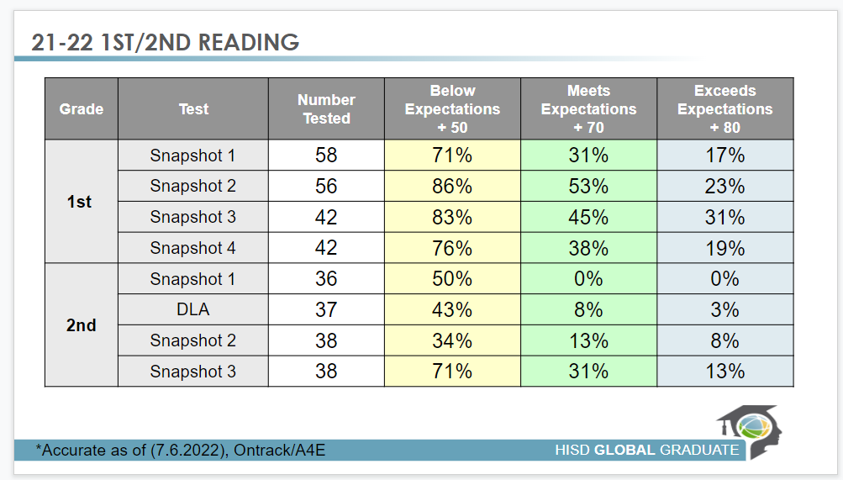

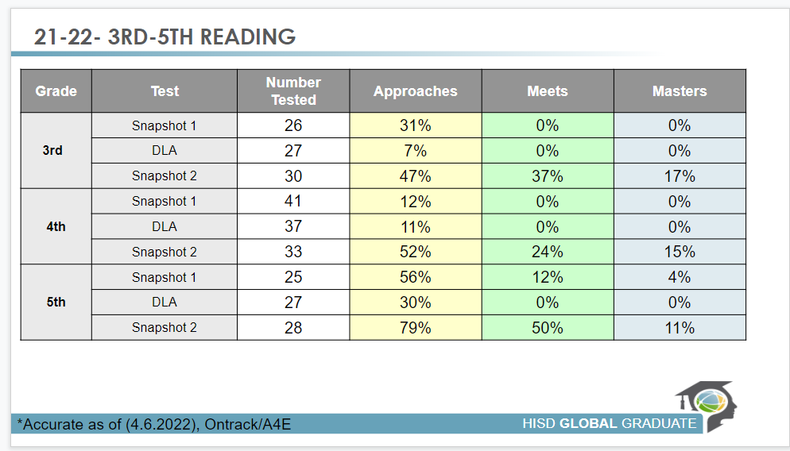

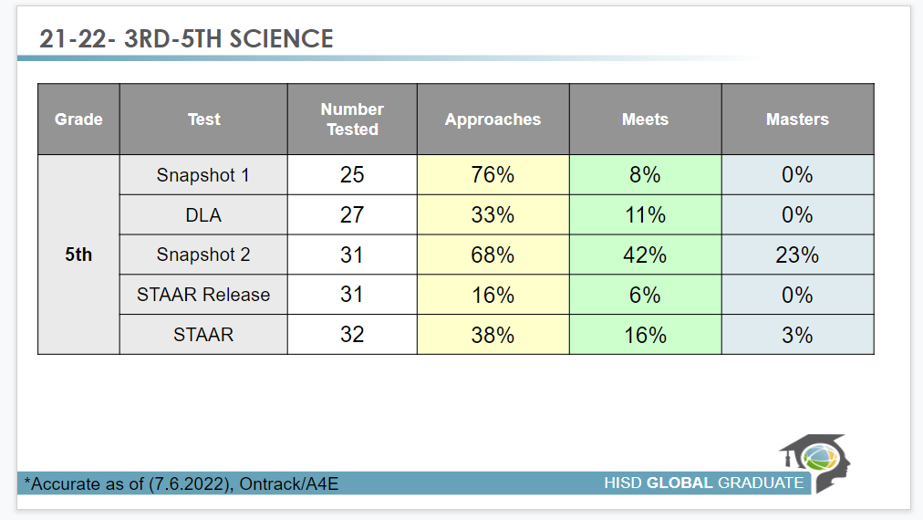

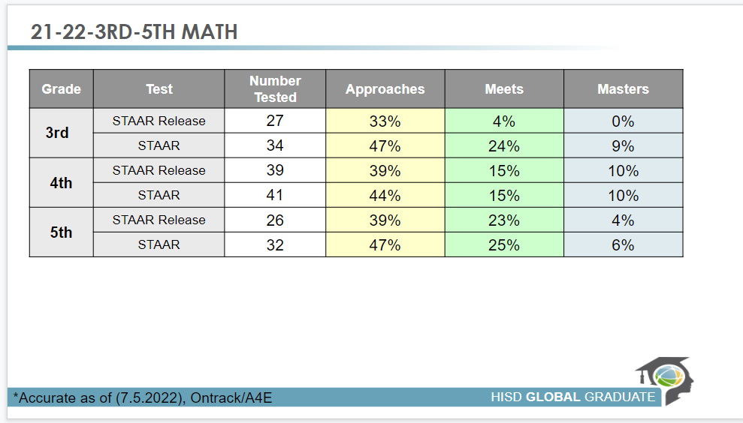

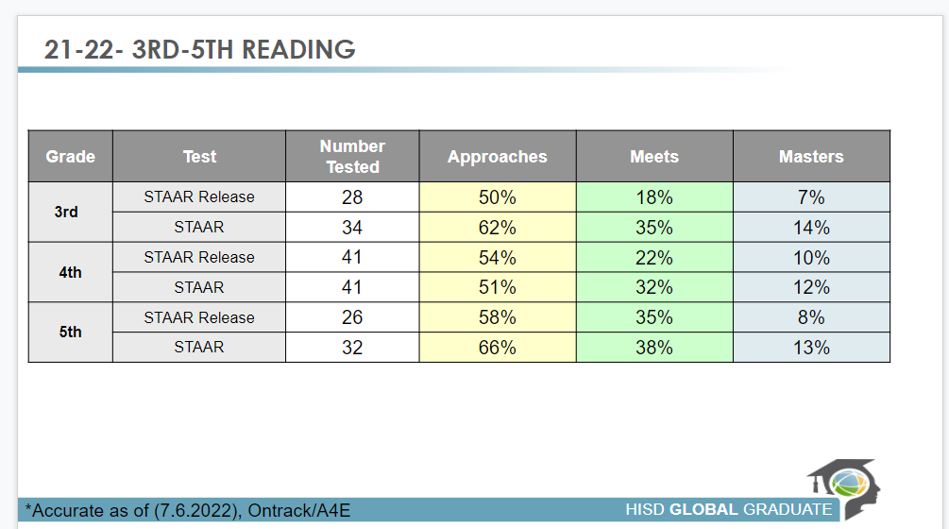

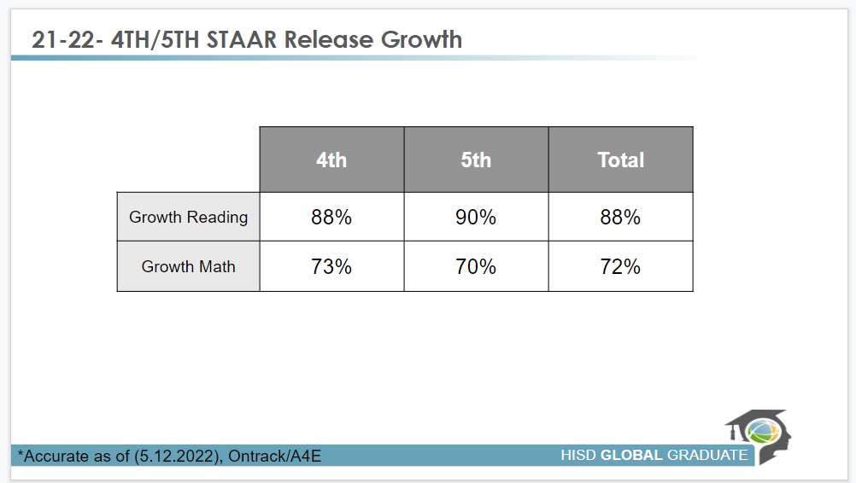

**From the Principal’s Pen**

***We are what we repeatedly do. Excellence, then, is not an act, but a habit.***

**-Aristotle**

**What I know for sure…**

1. **Students Learn by Doing**
2. Active participation engages students
3. Hands and minds on activities allow students to be active participants in their learning
4. High-yield instructional strategies help students grasp concepts
5. Instruction must have rigor and relevance
6. **Motivation Makes a Difference**
7. Extrinsic rewards help achieve results
8. Celebrating success and improvement is important
9. Your energy or lack of energy transitions to the students

1. **Environment is Essential**
2. School should be a warm inviting place
3. Classes should be print-rich
4. Maintaining organized and neat space is critical
5. **Expectations are everything**
6. People live up to high expectations and down to low expectations
7. Being fair, firm, and consistent is the best way to approach discipline
8. Without rules and order students cannot learn
9. Classroom/School routines and procedures should always govern how we operate day to day.
10. **My role as principal is to serve as a….**
11. Resource
12. Facilitator
13. Collaborator
14. Leader
15. Advocate
16. Lead Learner

**Hartsfield @ the CORE**

1. **Expectations**
2. Shared Vision and Collaborative Culture
3. Clearly Articulated Expectations for Success
4. Capacity Built to Accomplish Expectations
5. **Monitoring**
6. Review Instructional Calendars and Lesson Plans
7. Regular Classroom Observations
8. Review Student Products and Work Samples
9. Benchmark and Common Assessment Results
10. Implement Systematic and Strategic Interventions
11. Regular Review and Adjustments Based on Data
12. **Accountability**
13. Focus on Results
14. Everyone is Responsible for the School’s Success
15. No Excuses

**Profile of a Scholar**

**EFFECTIVE COMMUNICATOR** – Students will master the basic skills of reading, writing, comprehending, listening, and speaking, critical to daily life. They will be able to relate to others in an articulate, effective and efficient manner.

**PROFICIENT PROBLEM SOLVER** – Students will have the ability to make good decisions, handle problems and challenges and think systemically. They will interpret and process information, assess the current and desired situation, anticipate the potential outcomes and solve problems.

**INDEPENDENT WORKER AND THINKER** – Students will set priorities and goals, create options, develop plans of action, monitor and evaluate their progress. They will analyze their work and create multiple frames of reference to identify, assess, integrate and apply available information for meaning of action.

**TECHNOLOGY LITERATE** – Students will use technology to research, develop and complete classroom assignments and projects. They will demonstrate basic knowledge of computers and software.

**KNOWLEDGEABLE OF WORLDWIDE ISSUES** – Students will have basic knowledge of world issues, foreign affairs, politics and geography. They will be aware of current events and be able to discuss issues affecting the global economy.

**RESPONSIBLE CITIZEN** – Students will contribute their energy, time and talents to improve the welfare of themselves and others. They will have a sense of social responsibility and participate in the democratic process.

**Instructional Non-Negotiables**

**Purpose For Learning (PFL)** - Specially written on the board and stating to students what will be learned. ( I can statements)

**Daily Agenda** - List the daily schedule of experiences that occur during a specific time frame.

**Door Configuration** - Lesson plans, pacing calendar and daily schedule.

**Professional Development** – Be present and an active participant at team meetings.

**Student Work Samples**- All classrooms must have a section designated for student authentic products (no worksheets). Products should be quality, up to date, and graded.

**Student Data**– Current student data should be posted and/or readily accessible in the classroom. Student data is used to drive instruction and plan intervention.

**Student Data Binder/Data Conference**– Student data binders will be used for students to track their own growth through the data collected. The data binders can also be used as important evidence during parent conferences or PLCs to highlight successful best strategies and/or areas of concern. Student data binders should be updated within a week that the assessment was given. Data folders should reflect goals that have been set and reviewed during the teacher student conferences.

**Teacher Data Binder**– Teacher data binders will be used to track student data and their growth after every district/campus assessments within a week the assessment was given. Teachers are required to complete the data dig presentations and submit the information via sharepoint prior to the PLC.

**Interactive Word Walls** - Every class should have a functional (used during instruction and/or workstations). Word Wall that focuses on vocabulary that supports concepts previously/currently taught. **They are created as part of the instructional process and not as decoration.**

**Orderly Space** - All rooms must be **neat and well organized daily** according to the classroom setup protocol (model classroom). Room set up should consider how each area will link to instruction and help students become independent.

**Print-Rich Environment** - All classrooms must contain content and age-appropriate print (anchor charts, word wall, books, content posters, etc.) that allows students to interact and/or reference when needed.

**Instruction** - Lessons must allow students to take part in learning through real-world and hands-on activities. Worksheets and packets are not to be the only resource used during instruction.

* **Follow Respective Grade Level Instructional Plan**
* **Weekly Data Analysis**
* **Progress Monitoring As Required**
* **Manipulatives**
* **Hands-on Activities**
* **Critical-thinking Questioning**
* **Interactive Anchor Charts**
* **Small Group Instruction**
* **Gradual Release Instructional Model**
* **Maintain and Update Small Group Assignments**

**Grades** - Each teacher must update grade books weekly with the minimum grade requirements for their subject/grade. Each student MUST have a minimum of 2 grades per week in Math, 2 grades per week in ELA and 1 grade per week in Science and/or Social Studies. ***(2 grades per week in Science-3rd-5th grade)***

**Lesson Plans** – Plans are required weekly and should be submitted using the respective lesson plan template to your content supervisor. Lesson plans must be submitted by Wednesday of each week by 5pm. Lesson Plans will be submitted through Canvas.

**Do-Now** – Each student should complete a Do-Now upon entering the classroom. Do-Now’s should be corrected, collected, and/or recorded to establish the expectation that learning is always a priority and to determine the course of instruction.

**Technology-** The use of chrome books, laptops, document cameras, Interactive Whiteboards/Clevertouch, or other forms of technology to deliver instruction.

**Anchor Charts** - The purpose of an anchor chart is to anchor the teaching and learning that is happening in your classroom. The anchor chart should current and reflect the content that is being taught.

**Class Library -** The purpose of a class library is to allow students to have books readily available to read to enhance their vocabulary and strengthen their comprehension.

**Board Configuration** -Date, Daily objective, TEK(S)/ELPS, Agenda, Do Now, Extension Activity, Exit Ticket

**Shared Leadership Responsibilities**

**THE ADMINISTRATIVE TEAM**

**Travis Johnson, Principal**

* Provide leadership to campus Administrative & Leadership Teams
* Monitor Campus Data at all levels
* Create a system to monitor classroom observation and instructional support
* Create campus professional development plan
* Provide support in monitoring campus attendance
* Appraiser assignments
* Facilities and maintenance
* Finalize & Approve PLC structure
* Student Enrollment and Attendance
* Monitor campus finance and payroll systems
* Monitor Campus Data
* Support and maintain school discipline
* Provide leadership to campus Teacher Leaders & Office Staff

**Appraisal Assignments: C. Jackson, C. Lee, T. Oakley, B. Grimaldo,**

**M. Ross, S. Green, W. Bowie, A. Jones, D. Flores, P. Latoria, R. Godly, Johnson. S, LeRoy. S, M. Gibson, SLL Teacher, K. Brown-Hogan, C. Brown, L. Collins, K. Brown, T. Malreaux, D. Miller, SPED TA,**

**Dr. Cshenal Jackson, Assistant Principal, ELAR/SS**

* Campus Test Coordinator
* Monitor Literacy Content Data
* Lead Literacy PLC’s
* Monitor literacy interventions
* Support campus-wide literacy, interactive notebooks, and journaling initiative
* On Track Literacy Data Coordinator
* Develop and monitor Imagine assessment team
* PEIMS Coordinator
* Title 1 Coordinator
* LPAC Coordinator
* Special Populations
* Shelter Instruction
* 504 Coordinator

**Back-up Payroll/Budget Approver, HB 3**

**Appraisal Assignments: 5th ELAR, 3rd ELAR, 1st ELAR, T. George, T. Braziel, M. Howelton, C. Smith, N. Smith, A. Cormier, R Vitatoe**

**Clifford Lee, Magnet Coordinator**

* Monitor Campus Attendance
* Approve Magnet Applications
* Monitor Magnet Program and Student Enrollment
* Coordinate Magnet Events
* Monitor Magnet Content Data
* Back-up Student Enrollment and Attendance
* Campus Safety Team Coordinator
* Social Media Coordinator
* Safety Coordinator
* IAT Behavior
* School Discipline

**Event Leader: Magnet Fairs, Magnet Events, Campus Tours, Field Experience Coordinators**

**Grade Level: K – 5th**

**Appraisal Assignments:**

**Tammeka Oakley, Teacher Specialist, Science, Animal & Environmental Programs,**

* Monitoring interventions
* Monitor livestock and outdoor classroom garden
* Coordinate and monitor Animal Ambassador Program
* Tutorials/After School Interventions
* Intervention Assistance Team (IAT) Coordinator
* Intervention Coordinator
* HB 4545
* Progress Monitoring
* Campus Cloud
* Campus Induction Coordinator
* STEM
* Dyslexia
* GT Coordinator

**Event Leader: Family Science/STEM Night, STEM Expose, Math Family Night, Coordinate and Schedule Math Intervention**

**Grade Level: K – 5thScience**

**Appraisal Assignments: M. Gibson, SLL Teacher, K. Brown-Hogan, C. Brown, D. Miller, SPED TA**

**Lakita Roberts, Media Specialist**

* Formative Assessment Coordinator
* Technology
* Fix Assets
* Update School Website
* Social Media
* Update Marquee

**T. Maleaux, Counselor**

* Character Education classes
* Parent and Community Involvement
* Health
* Attendance
* Provide mental health support to students and teacher
* Will Participate in SATC meeting

**Rodney Godley, Wraparound Resource Specialist**

* Character Education classes
* Attendance\Home Visits
* Health
* Collaborate with CIS Student Support Program
* Connect campus and student with Tiers of support to address the academic and non-academic barriers to students
* Contribute to program planning, administration, implementation, monitoring, and the evaluation of program activities, including teamwork and building for the campus.
* Direct service delivery offered to students will focus on Walk-In Services, Supportive Mentoring and Community Liaison
* Will lead SATC meeting
* Will lead WAC

**Roles: Counseling, Community Services Liaison, Character Ed Chairperson**

**Event Leader: Career Day, Boys and/or Girls Day, Backpack Give-Away**

**Teri George, Reading Interventionist**

* Dyslexia Coordinator (Interventionist)
* Small Groups
* Literacy Inventory

**Vacant, Math Interventionist**

* Small Group Intervention
* Create Workstation
* Math Inventory

**Grade Level & Content Level Chairperson**

**Dr. Jackson (PK - 5th) ELAR**

**Mrs. Bowie (3rd - 5th) ELAR Support**

**(PK - 5th) Math**

**Mrs. Brown-Hogans (3rd - 5th) Math**

**Ms. Oakley (PK - 5th) Science**

**Ms. Roberts (3rd - 5th) Science Support**

**Mrs. LaToria (Pre-K3 - Pre-K4)**

**Roles and Responsibilities**

Documentation must be submitted weekly to the content leader

* Weekly meeting with agenda, sign in sheets, and minutes
* Send calendar invite to administrators
* Provide support to grade level/ content
* Conduct a meeting to disseminate information from the leadership meeting and bring concerns to the administration's attention.
* Serve as an accountability partner for all school related deadlines and duties
* Organize campus events

**Event Leader: STAAR Rally, Open House, Parent Nights, Team Meetings**

**Behavioral Expectations**

**Daily Rules**

The guiding principle for all daily rules is respect. We strive to create an environment where students learn to show respect for themselves, for others, and for their surroundings. Rudeness, unkindness, or malicious behavior, whether physical, verbal or written, will not be tolerated. This includes behavior in class, school assemblies, and while or school transportation. Throughout the day, students are expected to demonstrate the basics of courteous behavior. Students should say “please”, “thank you”, and “excuse me” when appropriate. Students should answer all adults with “yes/yes sir”, “no/no sir”, “yes/yes ma’am” or “no/no ma’am”.

**Assembly Behavior**

In assemblies or any formal gathering, students are expected to:

* Come to order and give their attention to the speaker when the hand signal is used.
* Refrain from all screaming – enthusiasm and approval can be and should be expressed by snapping or clapping.
* Wait to be dismissed by class
* Leave in a straight line with no talking. There should not be any pushing or crowding.

**Cafeteria Behavior**

During lunch, students are expected to:

* Enter the cafeteria in a straight and quiet line.
* Proceed to their assigned table.
* Come to order and give attention to the speaker when the hand signal is used.
* Only leave their assigned seat when given permission by the cafeteria monitor.
* Talk at a low tone. If the noise level is deemed too loud by a teacher, cafeteria worker, custodial staff, or school administration; students will be required to have silent lunches.
* All trash must be placed in the containers provided.

**Hallway/Common Areas**

* Because classes and other school activities are always in session, every effort must be made to maintain reasonable quiet and order in the hallways, entryways, and outside areas adjacent to classrooms and offices. All hallways are designated as quiet zones during instructional time.
* To maintain an atmosphere that is conducive to learning, electronic devices should not be powered on during school hours. Cell phones are to be turned into the teachers and locked in the file cabinet during school hours, except for school/classroom approved activity. Failure to do so may result in his/her being confiscated and/or a fine per district cell phone policy.

**Campus Cleanliness**

Maintaining the attractive appearance of the campus is the joint responsibility of all members of the community.

* Students and staff are asked to place all trash in trash cans (i.e., recycle, trash, etc.).
* Everyone is responsible for disposing of litter properly, whether one’s own or someone else’s. Eating or drinking is not allowed in the library, hallways, playing fields, or classrooms.
* Eating or drinking is not allowed in the classrooms unless a student has permission to do so from a teacher.

**Campus-wide Behavioral Expectations**

**NON – NEGOTIABLES**

**Walking in the Halls**

Hallways are “Quiet Zones”. Quiet Zones have been implemented so that instructional time is not disturbed during student transition. Students are to walk to the right of the halls in straight lines. Teachers are to ensure that students remain quiet, walk to the right and remain in a straight line.

**Accessing the Building**

During the morning arrival time, all students in grades 3rd through 5th should report to the cafeteria until dismissed to their assigned classrooms at 7:25 a.m. Students in Pre-K through 1st grade will enter the building through the rear annex doors and report directly to their assigned classes. Students are expected to remain quiet while in the cafeteria.

**Lunch**

All students should be escorted to and from lunch by their teacher. Teachers should ensure that all their students enter the cafeteria in a quiet and orderly manner. Teachers should ensure that students are dropped off and picked up from lunch at the designated time.

**Restroom Breaks**

All classes have designated restroom breaks. As students transition in the hall, they should adhere to the hallway “Quiet Zone” policy. It is expected that students traveling to the restroom outside of classroom restroom break time, should have a pass. These breaks should only be for emergency purposes or special situations.

**Hartsfield Fold Position**

The “Hartsfield Fold” technique teaches the behaviors and expectations that help students be courteous and respectful while in the common areas on campus. When implementing “Hartsfield Fold” in line, students should be quietly facing forward, standing feet together in their square with their arms folded in front of them. This is the school-wide expectation for all students when moving through the hallways.

**Campus-wide Academic Expectations**

**NON – NEGOTIABLES**

**Threshold**

The most important moment to set expectations in your classroom is the minute when your classroom students are about to enter or, if they are transitioning within the classroom, when they formally begin their lesson. When students cross the threshold into the classroom, you must remind them of the expectations. It’s the time to establish rapport, set the tone, and reinforce the first steps in a routine that makes excellence habitual.

**100 Percent**

Using 100 Percent ensures that all students are following a direction given in your classroom. If you don’t achieve this, you make your authority subject to interpretation, situation, and motivation. 100 Percent should be the standard and not the goal.

**\*\*Positive Framing\*\***

Make interventions to correct student behavior in a positive and constructive way. Corrections should be consistent and positive so that you can guide students to improved knowledge and action. A good practice to acknowledge another student or group of students who are exhibiting the desired behavior.

**\*\*Precise Praise\*\***

Make your positive reinforcement strategic. Differentiate between acknowledgment and praise. Acknowledge students when they meet your expectations. Praise students for when they exceed your expectations.

**Strong Start**

Design and establish an efficient routine for students to enter the classroom and begin class.

**Tight Transitions**

Quick and routine transitions that students can execute without extensive narration by the teacher is a critical piece of any highly effective classroom. In an effective classroom, transitions take less than thirty seconds, and often far less.

**Wait Time**

Allow students time to think before answering. If they aren’t productive with that time, narrate them toward being more productive.

**Do Now**

Use a short warm-up activity that students can complete without instruction or direction from you to start class every day. This lets the learning start even before you begin teaching.

**Exit Ticket**

End each class with an explicit assessment of your objective that you can use to evaluate your (and your students’) success. Make sure that the Exit Ticket Data Tracker is updated daily.

**S.O.A.R.**

Teach students key baseline behaviors for learning, such as sitting up in class and tracking the speaker, by using a memorable acronym **S.O.A.R.**, **S**it straight and tall; **O**nly watch the speaker, **A**lways listen, **R**eady to learn

**LEARNING EXPECTATION**

Because succeeding once or twice at a skill won’t bring mastery, give your students lots and lots of practice mastering knowledge or skills. By the end of independent practice, students should be able to answer questions to the standard they’ll be accountable for, and entirely on their own. Students should be able to solve questions in multiple formats and with a significant number of plausible variations and variables. Also, be sure to have bonus assignments to push students to the next level.

**Student Discipline and Behavior**

**\*\*Disciplinary Policies and Procedures\*\***

The school has the right to impose discipline and consequences for conduct occurring both on and off campus. **Students who commit minor infractions (i.e. talking out of turn, not bringing supplies, not following instructions, etc.) will be held to consequences on the teacher level (Level 1).** Multiple minor infractions may be treated cumulatively as a next level infraction (Level 2). Multiple Level 1 and Level 2 infractions are to be addressed using those interventions outlined by the Intervention Assistance Team (IAT). Those students with major infractions (Level 3 or 4) are to be referred to an administrator with substantial documentation to support the referral.

All classes will implement rules and consequences. Behavioral expectations will be posted in all classrooms.

**Out of School Suspension (OSS)-This MUST be a last resort.**

* Major violations of school rules (Level 3 & Level 4) **may** result in out of school suspension for 1 – 3 days.
* Students are not allowed on campus or to participate in afterschool programs including sporting events and field trips during the duration of the Out of School Suspension.
* Students are given **5 instructional days** to complete missing class assignments. It is the student’s responsibility to get makeup work from the teacher.
* Students will have the opportunity to make up assessments on the day they return to school.
* Hartsfield’s out of school suspension policy is aligned with the HISD Code of Student Conduct.

**Referral to a Disciplinary Alternative Education Program**

* The grade level dean or school principal may recommend a referral to a DAEP for a length of 15 – 45 days (Elementary) for repeated major offenses or a serious offense, even on the first offense, if a student’s continued presence is harmful to school or school community.
* When a student is referred to a DAEP, he/she is automatically suspended for 1-3 days. Upon completion of the suspension, the student **may be** placed in an alternative setting within the building until a decision is met on placement.
* Students are required to attend school each day he/she is assigned to the DAEP. Days are only counted as served when a student is physically present.

**Procedures for Disciplinary Infractions**

**A teacher is responsible for front line discipline in the classroom.** The following procedures are to be followed:

Determine the nature of the disciplinary action (refer to ***HISD Student Code of Conduct***). If the disciplinary action is a Level I or II:

**Clear Verbal Warning(s)** -Student clothespin (if applicable) will be moved down one step on the teacher’s behavior system chart. The warning(s) can be recorded on the ***Hartsfield Elementary School Behavior Corrections Form***, and/or in the teacher’s conduct folder.

**Documented Student/Teacher Conference**– The teacher will hold an individual or team conference with the student about their behavior. Parent contact will be made via the telephone, face-to-face, Wednesday Folders, letter, and/or email. The conference and the outcome of the conference will be documented on the ***Hartsfield Elementary School Behavior Corrections Form***, and/or in the teacher’s conduct folder.

**Isolation** - The teacher may choose to place the student in isolation inside their own classroom or in a classroom on the same grade level. Teachers must be clear that this is an opportunity for the student to change her/his behavior and compose her/himself in relation to the classroom expectations. During this time students should complete some type of reflection assignment. This incident can be recorded on the ***Hartsfield Elementary School Behavior Corrections Form***, and/or in the teacher’s behavior binder. **DO NOT PLACE STUDENTS OUTSIDE IN THE HALLWAY OR IN ANOTHER GRADE LEVEL CLASSROOM WITHOUT PRIOR APPROVAL FROM AN ADMINISTRATOR!**

**Documented Student/Teacher Conference w/Parent Contact** – The teacher will hold an individual or team conference with the parent about the student’s behavior. The parent conference can be held via the telephone or face-to-face. The conference and the outcome of the conference will be documented in Connect, on the ***Hartsfield Elementary School Behavior Corrections Form***, and/or in the teacher’s conduct folder.

**\*\* All Level 1 and Level 2 disciplinary infractions must be completed by the teacher in their Student Discipline Binder. \*\***

(Malicious behavior and that which presents immediate harm (i.e., some Level 3 and all of Level 4 infractions) to the students or staff warrant immediate referral to their administrator.) A copy of the referral and the administrator’s action will be returned to the teacher to be placed in the Student Discipline Binder.

**Removal of any student from the classroom is only done by an administrator. Students cannot be sent to the front office for disciplinary actions.**

**CONDUCT AND CONSEQUENCE QUICK LOOK**

|  |  |  |
| --- | --- | --- |
| **Level 1** | **Level 2** | **Level 3** |
| * Violations of classrooms or cafeteria rules and procedures * Failure to participate in classroom activities * Excessive tardies * Failure to bring/return classroom assignments / documents (i.e., homework, parent notes/letters, etc.) * General misbehavior (i.e., eating, horse-playing, excessive noise, dress code) * Disruption of instruction (i.e., excessive talking, walking, noises, etc.) * Failure to comply with campus-wide dress code   ***The following infractions warrant documentation in the teacher’s conduct log.*** | * Repeated disruption of instruction (i.e., excessive talking, walking, noises etc.) * Cheating * Use of electronics without permission * Inappropriate display of affection * Posting, displaying, distributing unauthorized material on campus * Accessing inappropriate sites on the Internet   ***The following infractions warrant immediate referral to the office and the completion of HISD Discipline Referral Form:***   * Leaving the classroom or school grounds w/out permission * Skipping class * Possession of flammable materials | * Chronic disruption of instruction (i.e., excessive talking, walking, noises etc.) * Failure to adhere to terms of behavior contract * Profanity, vulgar and/or obscene language and/or gestures * Bullying (i.e., verbal, written, and/or physical) * Vandalism   ***The following infractions warrant immediate referral to the office and the completion of HISD Discipline Referral Form:***   * Fighting or Assault * Stealing / theft of property * Possession of a weapon |

|  |  |
| --- | --- |
| **Brief Description of Infraction** | |
| **Brief Description of Outcome** | |
| **Teacher Signature:** | **Date:** |

**Students referred to an administrator MUST be accompanied with an HISD Discipline Referral Form completely filled out.**

**Student Dress Code**

**Uniform Policy**

**The fundamental reasons for the Hartsfield Elementary School Dress Code are to:**

1. Ensure the health and safety of everyone in the learning community.
2. Foster a positive, orderly school climate for optimal academic success.
3. Avoid any unacceptable disruptions to the learning environment.
4. Expose students to appropriate dress habits.

**Shirts:**

* Students must wear Hartsfield Logo collared (polo style) shirts:

Navy shirts, Red shirts, or Gray shirts

* All shirts must be worn tucked into bottoms
* Students are allowed to wear the school spirit or college shirt with jeans on Fridays (only)

**Bottoms:**

* **Boys**- may wear khaki or navy bottoms
* **Girls**- may wear navy or khaki knee length shorts
* **Girls** -may also wear khaki or navy pants
* All bottoms must be secured with a belt **(no sagging)**

**Head Coverings:**

* **Hair must be neatly combed and clean in appearance.** The following hair grooming items are prohibited: metal rakes, combs, brushes, wrap scarves, bandanas, wave caps and alike
* Hats are not allowed to be worn in the building.

**Jackets:**

**ONLY** school issued hoodies are allowed in school. No exceptions.

**Shoes:**

* **All shoes must be closed toe and back**
* **No flip flops, sandals, or Crocs**

**Backpacks:**

* Backpacks are considered part of the necessary school supplies needed every day for school. Backpacks should be clear and contain only essential school material and supplies. Backpacks and purses are subject to be searched at any time.

**Jewelry:**

* Expensive or irreplaceable jewelry should not be worn
* Jewelry depicting or making references to drugs, alcohol, or vulgar/obscene language may not be worn.

**Body art or piercing should not be exposed; boys are not permitted to wear earrings.**

**Electronic Devices:** Air Pods, cell phones, and handheld game systems are **not allowed.**

**CELLULAR PHONES:**Cell phones will be taken up daily and locked in the homeroom teachers cabinet. Cannot be used during the instructional day. Cell phones used during the instructional day will be collected and parents will be subject to a **$15.00 processing fee**.

**Violation of the dress code can result in detention and repeated violations can result in Out of School Suspension (OSS).**

**Dress Code MUST be enforced by all staff members!**

**REASONS FOR**

**NON-RENEWAL**

|  |  |
| --- | --- |
| Houston ISD |  |
| 101912 |  |
|  |  |
| TERM CONTRACTS | DFBB |
| NONRENEWAL | (LOCAL) |

PREAMBLE: TRANSFORMATION OF POLICY REGARDING CONTRACT RENEWALS

In accordance with its data-driven culture, the District is including as a reason for nonrenewal insufficient student academic growth as reflected by value-added data.

REASONS

Research has reinforced the significant influence teachers have on student achievement. Specifically, research shows that a significant percent of the variance in student academic progress levels is attributed to the classroom teacher (Ballou, D., Sanders, W., and Wright, P. “Controlling for Student Background in Value-Added Assessment of Teachers.” *Journal of Educational and Behavioral Statistics,* Spring 2004, Vol. 29, No. 1, pp. 37-65). Furthermore, in a comprehensive study on teacher impact, data indicate that students who start third grade at about the same level of mathematics achievement finish fifth grade mathematics at dramatically different levels depending on the quality of their teachers. (Haycock, Kati. “Good Teaching Matters… A Lot.” *Education Trust*. Thinking K–16, Vol. 3 Issue 2: 1998).

The recommendation to the Board and its decision not to renew a contract under this policy shall not be based on an employee’s exercise of Constitutional rights or based unlawfully on an employee’s race, color, religion, sex, national origin, disability, or age. Reasons for proposed nonrenewal of an employee’s term contract shall be:

1. Deficiencies pointed out in observation reports, appraisals or evaluations, supplemental memoranda, or other communications.
2. Failure to fulfill duties or responsibilities.
3. Incompetency or inefficiency in the performance of duties.
4. Inability to maintain discipline in any situation in which the employee is responsible for the oversight and supervision of students.
5. Insubordination or failure to comply with official directives.
6. Failure to comply with Board policies or administrative regulations.
7. Excessive absences.

|  |  |  |
| --- | --- | --- |
| DATE ISSUED: 4/18/2012 |  | 29 of |
| LDU 2012.02 |  |
| DFBB(LOCAL)-X |  |

1. Conducting personal business during school hours when it results in neglect of duties.
2. Reduction in force because of financial exigency.
3. Reduction in force because of a program change.
4. Termination of a term contract employee resulting from being displaced by a continuing contract employee, when that employee has been identified for reduction in force.
5. Drunkenness or excessive use of alcoholic beverages; illegal use of drugs, hallucinogens, or possession, use, or being under the influence of alcohol or alcoholic beverages while on school property, while working in the scope of the employee’s duties, or while attending any school- or District-sponsored activity.
6. The illegal possession, use, manufacture, or distribution of a controlled substance, a drug, a dangerous drug, hallucinogens, or other substances regulated by state statutes.
7. Conviction of a felony or of any crime involving moral turpitude; conviction of a lesser included offense pursuant to a plea when the original charged offense is a felony; or deferred adjudication for a felony or any crime involving moral turpitude*.* [See DH]
8. Failure to report any arrest, conviction, or deferred adjudication for any felony or any crime involving moral turpitude as required by policy. [See DH]
9. Failure to meet the District’s standards of professional conduct.
10. Immorality, which is conduct the Board determines is not in conformity with the accepted moral standards of the community encompassed by the District. Immorality is not confined to sexual matters, but includes conduct inconsistent with rectitude, or indicative of corruption, indecency, or depravity.
11. Failure to comply with reasonable District requirements regarding advanced coursework or professional improvement and growth.
12. Disability, not otherwise protected by law, that prevents the employee from performing the essential functions of the job.
13. Any activity, school-connected or otherwise, that, because of publicity given it, or knowledge of it among students, faculty, and community, impairs or diminishes the employee’s effectiveness in the District.
14. Any breach by the employee of an employment contract or any reason specified in the employee’s employment contract.
15. Failure to maintain an effective working relationship, or maintain good rapport, with parents, the community, or colleagues.
16. A significant lack of student progress attributable to the educator.

|  |  |  |
| --- | --- | --- |
| DATE ISSUED: 4/18/2012 |  | 2 of |
| LDU 2012.02 |  |
| DFBB(LOCAL)-X |  |

1. Behavior that presents a danger of physical harm to a student or to other individuals.
2. Assault on a person on school property or at a school-related function, or on an employee, student, or student’s parent regardless of time or place.
3. Use of profanity in the course of performing any duties of employment, whether on or off school premises, in the presence of students, staff, or members of the public, if reasonably characterized as unprofessional.
4. Falsification of records or other documents related to the District’s activities.
5. Falsification or omission of required information on an employment application.
6. Intentional or deliberate misrepresentation of facts to a supervisor or other District official in the conduct of District business.
7. Failure to fulfill requirements for certification, including passing certification examinations required by state law for the employee’s assignment.
8. Failure to achieve or maintain “highly qualified” status as required for the employee’s assignment.
9. Failure to fulfill the requirements of a deficiency plan under an Emergency Permit, a Special Assignment Permit, or a Temporary Classroom Assignment Permit.
10. Any attempt to encourage or coerce a child to withhold information from the child’s parent or from other District personnel.
11. Any reason that makes the employment relationship void or voidable, such as a violation of federal, state, or local law.
12. Insufficient student academic growth as reflected by value-added scores.
13. Any reason constitutes good cause for terminating the contract during its term.

RECOMMENDATIONS FROM ADMINISTRATION

Administrative recommendations for renewal or proposed nonrenewal of professional employee contracts shall be submitted to the Superintendent. A recommendation for proposed nonrenewal shall be supported by any relevant documentation. The final decision on the administrative recommendation to the Board on each employee’s contract rests with the Superintendent.

The Superintendent shall identify employees whose contracts are recommended for renewal or proposed nonrenewal by the Board. The Board shall consider the reasons in support of the proposed nonrenewal and shall

|  |  |  |
| --- | --- | --- |
| DATE ISSUED: 4/18/2012 |  | 3 of |
| LDU 2012.02 |  |
| DFBB(LOCAL)-X |  |

SUPERINTENDENT’S RECOMMENDATION

then act on all recommendations. [See DFBB(LEGAL)]

NOTICE OF PROPOSED NONRENEWAL

After the Board votes to propose nonrenewal, the Superintendent or designee shall deliver written notice of proposed nonrenewal in accordance with law.

Upon receiving notice of proposed nonrenewal for any reason, an employee on a performance contract shall not request a hearing or contest the proposed nonrenewal in any administrative or judicial forum. [See DCE(LOCAL)]

If the notice of proposed nonrenewal of a Chapter 21 term contract does not contain a statement of the reason or all of the reasons for the proposed action, and the employee requests a hearing, the District shall give the employee notice of all reasons for the proposed nonrenewal in a reasonable time before the hearing. The initial notice or any subsequent notice shall contain the hearing procedures.

REQUEST FOR HEARING

An eligible employee who desires a hearing after receiving the notice of proposed nonrenewal shall notify the Board in writing not later than the 15th day after the date the employee received the notice of proposed nonrenewal.

HEARING PROCEDURES

The hearing shall be conducted by an independent hearing examiner in accordance with the process described at DFD(LEGAL).

BOARD DECISION

Following the hearing, the Board shall take appropriate action in accordance with Chapter 21 of the Education Code and policy DFD.

NO HEARING

If the employee fails to request a hearing, the Board shall take the appropriate action and notify the employee in writing of that action not later than the 30th day after the date the notice of proposed nonrenewal was sent.

|  |  |  |
| --- | --- | --- |
|  |  | 4 of |
|  |  |
|  |  |
|  |  |

**EXCELLENCE**

**ARTICULATED**

|  |
| --- |
| **Operational Procedures** |

**DAILY SCHEDULE**

The school year shall consist of a minimum of 180 instructional days. Instruction should occur not less than 7 hours including lunches and recesses. Teacher daily duty schedules are based on a 7-hour and 45-minute workday.

**SCHOOL HOURS**

**Breakfast in the Classroom** ……………………………………… **7:30 a.m. - 8:15 a.m.**

**School Hours (M-F)** ...…………………..………………………… **7:30 a.m. - 2:55 p.m.**

**Students are tardy at 7:45** ……………………………………….. **Dismissal at 2:55 p.m.**

**ALL TEACHERS: 7:20 a.m. - 3:05 p.m. (M-F)**

**Dismissal Duty: 2:55 p.m. – 3:05 p.m. (Dismissal Duty)**

**Breakfast will not be served after 8:15 am**

**TEACHERS SIGN IN/SIGN OUT**

**Texas Education Agency** policy must be followed for sign in/sign out procedures. Every employee must sign in and out using the TimeTrax keypad. Traditional timesheets will be used in special situations. **Teachers should sign in no later than 7:20 a.m. and sign out no earlier than 3:05 p.m. (M-F).** The time on the Time Trax device is considered the official school time. It is recommended that you sync your time pieces accordingly.

Please be reminded that the following are **NOT** permitted:

Starting the school day without signing in or ending the school day without signing out. (Do not go to your class then sign in later)

**DAILY SCHEDULE FOR TEACHERS**

**Arrival Procedures**

Teachers must be prepared for duty by 7:25 a.m. Specifically, teachers should be standing at their classroom door ready to receive their students at 7:25. **Teachers are not permitted to pick up students of another teacher, unless otherwise arranged by an administrator**.

**Dismissal Procedures**

Teachers should escort their students to the assigned dismissal areas and assist with dismissal supervision until 3:05 pm, unless otherwise arranged.

**TARDINESS**

A conference will be held for all campus personnel where excess tardies (3 or more) are a concern. Excessive tardies will result in formal documentation.

**TEACHER ABSENCES**

Please follow the procedures below:

* For a “planned absence”, you are expected to:
  + Complete an ***Absence From Duty Form***
  + Place the form in the designated bin in the main office by 3:15 p.m.
  + Enter absence into OneSource
  + Get approval from the principal
  + Enter absences into AESOP, unless informed by an administrator
  + All planned absences must be submitted at least 24 hours in advance.

To report “same day absences”, state the reason for your absence when you **call** the principal, Mr. Johnson and do not call later than 6:00 a.m. in order to secure a substitute. Make sure you follow the protocol list in order to report an absence if you are unable to reach someone.

* + **Principal Mr. Johnson 713-550-3438**
  + **Assistant Principal Dr. Jackson 940-632-9675**
  + **Magnet Coordinator Mr. Lee 713-304-1661**
  + **Administrative Assistant Ms. Ross 832-439-1178**
* Substitute bins including lesson plans and class assignments should be easily accessible in your classroom. Substitute folders must be turned into the office and updated as needed. It should include:
* Class rosters
* Class Agenda (Lunch, Ancillary, Restroom Breaks, Planning Schedule, Pull-outs/Push-ins, etc.)
* Disciplinary Forms
* Emergency Roster and Plans
* Emergency Contacts on Campus
* For same day absences the office staff will give your substitute a substitute folder upon arrival. After a same day absence you should update class assignments in the Substitute Bin. **Also, folders are to be updated each month.**
* If coverage cannot be provided, classes will be divided. With this in mind, when planning activities for your sub, please provide assignments that can move with scholars. Make sure you have a class split list in the Substitute Folder.

**JURY DUTY**

Complete the ***Absence From Duty*** and submit to the administrative assistant in order to secure a substitute. Upon returning from jury duty, you are to submit the ***"Jury Duty Work Release"*** form to Mr. Johnson.

**LEAVING THE BUILDING**

Campus employees are **NOT** to leave the campus during working hours, which includes your planning period, without notifying your appraiser. Once **approved**, you must **sign out and back in** using the thumb print system located in the main office.

Doctor’s appointments, etc., should be scheduled for after school hours. But in the case that you have a doctor’s appointment during your work hours, you must first get approved by your appraiser. Once **approved**, you must **sign out and back in** using the thumb print system located in the main office.

**Note: Requests to leave early that are approved will be deducted (docked) from your “Personal Leave” bank.**

**BOARD POLICY REGARDING LEAVE**

The following are School Board/District recognized holiday dates:

September 5, 2022 Labor Day

October 5, 2022 Fall Holiday

November 21 – 25, 2022 Thanksgiving

December 22, 2022 – January 4, 2023 Winter Break for Teachers

December 22, 2022 – January 4, 2023 Winter Break for Students

January 16, 2023 Martin Luther King Day

March 13 – 17, 2023 Spring Break

March 31, 2023 March 31, 2023

April 15, 2023 Spring Holiday

April 21, 2023 Spring Holiday

May 29, 2023 Memorial Day

***Note: Positions less than twelve months are not eligible for vacation requests. Also, absences the day before and/or the day after an approved board/district holiday are not permitted.***

Compensated leave provided by the district for specific absences are listed below:

**a. Personal illness** Employees may be absent with full pay in case of such personal illness that makes it undesirable for the employee to be at his/her work because of medical disability resulting from illness, injury, pregnancy, or medical and dental appointments. **Three consecutive personal illness days require a doctor’s note to return to duty.**

**b. Family illness** All employees may be absent with full pay in case of illness of a member of the employee’s immediate family (husband, wife, child, brother, sister, father, mother, grandparent or grandchild); this relationship, where applicable, may be by affinity or consanguinity.

**c. Personal Business** Employees may use two (2) days of leave time per year at full pay to dispose of personal business that cannot be conducted outside of regular work hours. Employees may use an additional one (1) day of leave time per year at full pay as a discretionary day for any reason. These days shall be deducted from the employee’s personal leave balance.

All applications stating the reason for a personal business leave day shall be filed in writing with the principal or appropriate administrator at least **48 hours prior** to the time for which the leave is requested (except in an emergency). Personal Business shall not be used to extend vacations or scheduled school holidays. Personal Business forms are located in the main office.

**d. Family Emergencies** An employee may be absent with full pay for a family emergency and shall be limited to natural disasters and life-threatening situations involving the employee or a member of the employee’s immediate family. Upon returning to duty, the employee must submit a written detailed statement to the principal explaining the circumstances.

**e. Funeral Leave** Employees may be absent without loss of pay and without personal leave deduction in the case of death of a mother, father, husband, wife, or child for a period not to exceed three days per occurrence.

**Field Experiences**

**Educational field experiences will be taken regularly.**

* All field experiences must be linked to educational objectives
* Field experiences must be requested 4 weeks in advance (in order for a request to be complete all documents must be submitted)
* Field experience lesson plan, HISD field trip request, HISD bus requisition,   
  AF-104 is required for all field experiences (that involve fund collections), and field experience permission slip are documents required to plan a field experience
* In order for parents to serve as volunteers, they must submit to a ***Criminal History Background Check*** and they must complete the ***VIPS Registration*** online via the HISD Portal. This process must be completed prior to their involvement with any student.

**MONEY COLLECTIONS:**

(a) **On or before 12 noon, 7 days prior to the field experience, all money collected must be turned in to Ms. Walker accompanied by an AF-104 properly filled out.**

(b) Do not overcharge for field trips, etc. Where pennies are involved, please calculate to the next dollar.

(c) **All monies collected should be turned in at the end of the work day.** **No money should remain in your possession overnight. District policy indicates that all funds collected over twenty dollars should be submitted for accounting.**

(d) **Never leave money in your classroom. If you have collected money from the children and you leave it in the classroom, you will be held responsible for this money. Please prepare AF-104 before submitting money.**

**Field trip money must be turned in to the school secretary PRIOR to the field trip.**

**Communication**

**E-MAIL AND MAILBOXES**

Open lines of communication leads to successful practices. With this in mind, staff members are required to check emails, mailbox, HUB portal, and campus message board daily. Campus business will be conducted through these channels. Sending emails is prohibited during instructional time, unless requested or authorized.

**TELEPHONE**

Telephone messages will be placed in your mailbox. If there is an **EMERGENCY**, someone from the office will inform you of this emergency call. **Cellular phone usage is prohibited during instruction and in common areas (hallways, offices, cafeteria, and alike).** **Cell phone usage includes sending and reading text messages, mobile internet browsing and mobile device games.** Parents should not be contacted via cellular phone during instructional time. Parent contact should be made via campus phone line.

**ANNOUNCEMENTS**

All announcements must be placed in the announcement tray under the white board in Mrs. Ross' office **the day prior to** the announcement.

**PROFESSIONAL DEVELOPMENT (PD) MEETINGS find out when Jasmine is here**

Professional Developments meetings are held every Tuesday unless otherwise noted. These meetings are reserved to cultivate the craft of teaching and learning therefore attendance is expected from the entire faculty and staff. Any non-attendance should be communicated to the content supervisor prior to the meeting date and time. Every effort will be made to relay all other informational items electronically via the HUB. It is your responsibility to seek information given during PD from your team leader and/or appraiser.

**PARENT-TEACHER COMMUNICATION:**

The teacher shall:

* Initiate a conference when a student is not progressing satisfactorily.
* The conference must be scheduled during the teacher’s conference period. It shall never be held during instructional time.
* Have samples of the student’s work and the grade book available for review by the teacher and parent at the parent conference.
* Present the student’s behavior patterns in a positive and professional manner.
* Prepared to discuss the student’s classroom participation and work.
* Work with the parent to solve the problem.
* Maintain a parent contact log along with date, time, minutes, agreements, and signature in the teacher’s professional portfolio.

**A record must be maintained of parent conferences, contacts, or student evaluations and must be readily available for administrative review at any time. These records must be filed at the end of the year with the Lead Office Clerk.**

|  |
| --- |
| **Professionalism** |

**Telephone**

There are telephones available in the classrooms. The purpose of installing phones in the classrooms is to make parent contact and other school related contact more convenient. Teachers are asked not to issue the school’s phone number for personal phone calls or personal business. This overloads the office staff with unnecessary phone calls.

**Parent phone calls should be done during planning time only**

**Visitors**

Teachers should not have visits by outsiders during the instructional day, unless it is school business that has prior approval from administration. ***All visitors must check into the main office***. Faculty members’ children or spouses are not to be brought to school during the instructional day unless approved by the principal. This also includes teachers visiting other teachers’ classes during instructional time.

**Lunch**

All teachers are entitled to a 30 minute duty-free lunch period daily. Please be sure that you clean all areas after eating. If you store food in the lounge refrigerator, please discard it. The custodial staff will clean the lounge refrigerator weekly. ***Office personnel are prohibited from eating at their desk and/or in their classroom during instruction.***

**Dress Guidelines**

The faculty and staff at Hartsfield must always maintain professional dress standards as an example for our students. The collective appearance of the faculty is important; the impressions that we create for the students, parents and community are lasting, thus we must be properly groomed and have a professional appearance. Clothing should be neat and clean at all times, extreme styles are inappropriate if they indecently expose or disrupt the educational process. The following clothing items are considered unprofessional:

1. Torn garments, pants, jeans, shirts, and etc.
2. Uncombed and un-groomed hair
3. Blue jeans other than Fridays, Go Texan Day, or any other district designated day
4. Strapless tops and dresses, spaghetti strap tops or dresses (without an over shirt or jacket)
5. House slippers, flip flops, crocs, sandals without a heel strap, and tennis shoes ***(shoes must be closed in the back or front.)***
6. Shorts (except the physical education teacher)
7. Body Art or Piercing should not be exposed

**When in doubt don’t wear it!**

**HARASSMENT POLICY**

Employees are guaranteed a workplace free from harassment. Harassment occurs when the receiver feels that the environment is hostile, offensive or intimidating. Furthermore, if an individual’s working environment is such that their job is interfered with, or if employment opportunities are interfered with, this is defined as harassment. If an employee is being harassed, he or she needs to report the harassment to a supervisor and the supervisor will take corrective action. See the HISD Board Policy ***DGBA, DIA (LEGAL)***

**GRIEVANCE PROCEDURES**

Houston ISD has a published grievance procedure. Complaints shall be made in writing to the Principal. HISD Board Policy ***DAA (LEGAL)*** is located in the Board Manual Online.

**Student Attendance**

**ADMISSION SLIPS**

When a newly enrolled child enters your classroom, obtain his/her admission slip or schedule and file it in the child’s folder. If you have reason to believe the child should not be in your class, please check with the registrar.

**ATTENDANCE PROCEDURES**

(a)Attendance check will be conducted at 8:30 and submitted to the front office. Official attendance will be taken at 9:30 a.m. in Grade Speed.

It is highly important that this responsibility is carried out efficiently since attendance records serve as the basis for computing average daily attendance (ADA) figures on which state funds are distributed. Students with medical appointments who are out of class at the time attendance is taken maybe counted present, provided they are in attendance at some time during the school day.

(b) Accept in your classroom only those students who are on your class list and those for whom you have an admission slip or schedule.

(c) A count of all absences (excused and unexcused), days present, and tardies should be kept by the classroom teacher.

(d) ***Excuses for absences and tardies are: personal illness, sickness or death in the family, quarantine, weather or road conditions making travel dangerous, participation in school activities with permission of the principal, and emergencies or any other cause acceptable to teacher, principal, and/or superintendent.***

**ATTENDANCE/ABSENCE**

Consistent attendance in school is essential to promoting good student performance and attitude. ***Our goal is 98% attendance.***

Students who have been absent or tardy **MUST** present the teacher with a **written excuse signed by the parent/guardian within 3 days of the absence or tardy**. Written excuses are to be submitted to the Attendance Clerk on that day. All students will be given the opportunity to make up work when absent. **Students will be excused from attending school for the purpose of observing religious holidays when it is a belief of their faith, provided a written request is sent in advance by the parent or guardian.**

**Attendance trackers will be kept in teacher’s classroom and updated weekly by designed staff members as follows:**

**Pre-K 3 and 4: Ms. Maria/ Ms. Hancock**

**K - 2: Ms. Malveaux**

**3 - 5: Mr. Godly**

**EXCESSIVE TARDINESS POLICY**

Students who are tardy more than 3 times receive written notification to parents by the teacher and may result in grade reduction due to missed instructional time. Students are tardy after 7:35 a.m.

The "Excessive Tardiness Policy" will be in effect for the 2022-2023 school year and will consist of the following:

(a) A student is considered tardy after 7:35 a.m. absent after 9:30 a.m.

(b) Excessive tardiness is defined as any student being tardy more than five (5) times per nine-week grading period.

(c) Any student exceeding the five (5) tardy maximum per nine-week period will be excluded for 4 weeks from participating in extracurricular activities (field trips, choir, cheerleaders, recess, etc.).

(d) Excessive tardiness may be recorded on the student's report card in the "Comment Section." Since valuable instruction time is missed when the student is consistently tardy, comments might include *"Not using their time effectively due to excessive tardies/absences."*

(e) Excessive tardies are to be documented and entered in PowerSchool.

**CHECK-OUT DURING THE DAY**

If a parent must pick up his/her child before the end of the school day due to an emergency, the parent should notify the teacher in writing or telephone the office so that the teacher will have the child prepared. This will help to minimize the disruption for all concerned. Parents must come to the office and sign their child out. We can only release the child to a parent or the designated emergency contact person listed on the child’s enrollment card. ***For the child's protection, we will ask for identification.***

Parents should not expect to take their child out of school early every day. Students miss valuable instruction when they are dismissed early. During dismissal, parents will not be able to check-out scholars between 2:15 p.m. and 2:55 p.m.

**EMERGENCY PHONE CALLS MADE BY STUDENTS**

The school telephones are for emergency use only by the students. **Students who need to make a phone call should be supervised by their teacher and allowed to make the phone call from the classroom phone. Students are not to be sent to the office to make phone calls before, during, or after school.** Please be cautious of sending students to the office to make phone calls regarding matters that could be handled during non-instructional time.

Parents are to make prior arrangements with their child for procedures after school, on rainy days, and on the occasions of early dismissal. We do not accept telephone messages for students except in emergency situations. We do ask that these messages be kept to a minimum. This should always be enforced.

**HALL PASSES**

Students must have a hall pass if they are in the halls for any reason without their class. Student use of hall passes during the school day should be limited. **Students should not be sent on errands during instructional time.**

* **Hallway**
* **Nurse**
* **Restroom**

**SENDING STUDENTS TO THE OFFICE OF THE PRINCIPAL**

Students who are determined to be persistently disruptive to the educational process should be referred to the office with a **properly completed discipline folder**. **Students are NOT to be placed in the halls as a form of discipline.**

**SUPERVISION OF STUDENTS**

Teachers are expected to escort their students to their ancillary classes. In the event that the ancillary teacher is running behind schedule, it is expected that the teacher will notify the front office, stand by the door of the ancillary classroom, and actively monitor students until someone comes to relieve them. These procedures are necessary in order to maintain the safety of our students. **Do not leave students unsupervised**.

**Always notify the front office in the event there’s an emergency and your class needs supervision.**

**Lunch and Restrooms Procedures**

**BREAKFAST/LUNCH**

Breakfast is free for all students. All students will participate in the Breakfast in the Classroom program. Students may purchase their lunch at school or bring lunch from home. Those who bring lunch may purchase milk or a-la-carte items. **Glass bottles are not allowed at school.**

**FREE OR REDUCED MEALS**

Children from families whose income meets established guidelines will qualify for free or reduced priced meals. Applications and guidelines for this program are available in the office.

If a **child forgets** his/her breakfast and/or lunch money or lunch

a. Students will be served a sack lunch with milk.

b. The parent may bring the forgotten lunch or money to the office, and it will be given to the child. HISD lunch menus are available online found in the Nutrition Services.

**CAFETERIA RULES**

All elementary teachers are strongly encouraged to eat with their students. **All teachers are expected to review cafeteria table manners and rules during the first week of school.**

* Enter the cafeteria with lunch card/ID#.
* Enter and exit the cafeteria in a quiet, orderly fashion.
* Sit at an assigned table and use soft voices.
* Clean up after yourself.
* Keep hands and feet to yourself.
* Respect all adults and peers.
* Remember table manners.
* Do not share food, drink, or money with anyone.
* Cafeteria food or snacks **must not** be removed from the cafeteria.
* Additional items cannot be purchased once you are seated at your table.

**RESTROOM RULES**

Please escort your students to the restroom and stay with them during this time. Each class will have an assigned restroom time as established by grade level team members. Assign a restroom monitor to see that the desired conduct is exhibited at all times while in the restroom. ***EACH TEACHER IS TO CHECK BOTH RESTROOMS BEFORE AND AFTER HIS/HER CLASS LEAVES*.** Explain to students the importance of going to the restroom during the assigned time, students will not be allowed to use the restroom during instructional time. Students are to use proper restroom manners at all times.

* Always flush the toilets.
* Keep the restroom clean at all times.
* Put all the trash in the trash can.
* Report any vandalism to the teacher immediately.

**Clinic Procedures**

**MEDICATIONS**

**HISD Board Policy and procedures state that it is not the function of public school personnel to administer medical treatment including over-the-counter drugs**.

Teachers and other school personnel are expected to limit themselves to the usual and accepted practices of first aid in managing emergencies due to sickness or accident.

Students on long-term medication which cannot, under any arrangement, be administered other than during school hours may take medication at school with a written physician’s statement and a properly completed medication form (40.3750). All medication will be maintained in the Clinic and administered by the registered school nurse on duty.

1. The registered nurse is on duty to care for students’ every day.
2. When a student becomes ill at school, the teacher or substitute fills out a clinic form and sends the student to the nurse's office.
3. The student may be excused to go home after the parent or guardian has been notified. Such excuses are granted by the principal, nurse, or another person designated by the principal.
4. The nurse is not permitted to give children and teachers medicine, including aspirin, unless there is a signed form by the parent and the physician, which gives explicit instructions concerning the medicine.
5. In order for a student to **not** participate in P.E., he/she must have a written excuse from his/her parents and/or physician.
6. Each classroom is provided a first-aid kit for minor scrapes. Teachers should make use of this kit.

**Textbooks and Library Books**

**TEXTBOOKS AND LIBRARY BOOKS**

Teachers are responsible for all textbooks and library books issued to them. Students are not to write in books. Parents and guardians are financially liable for any damage or loss that may occur while any book is in their child‘s possession. We will not issue a new textbook to a student to take home unless we receive money for the lost book

**LIBRARY PROCEDURES**

1. First through third grade students are allowed to check out one book. The book is due the following week.
2. Fourth and fifth grade students are allowed to check out two books. The books are due the following week.
3. If a book is misplaced, students cannot check out another book until the lost book has been found or paid for.
4. There are no fines or charges for overdue books.

**RESPONSIBILITY FOR TEXTBOOKS**

You will be given a list of the items received at the time of textbook checkout. This is the time to point out any errors of count. You are responsible for textbooks, workbooks, kits, etc., once you sign for them.

Teachers are responsible for all textbooks issued to them. This responsibility may be transferred to the individual student, provided a record by title and book number is kept for each book issued to the student. The student can be held responsible only for the books issued to him/her.

Lost and found textbooks are kept in the office separate and apart from the other books stored in the Bookroom. Lost and found books will be returned to the teacher after verifying the title and number of the lost book.

**FOR YOUR OWN BENEFIT, DO NOT BORROW OR LEND YOUR TEXTBOOKS.**

The Textbook Clerk only knows the book record that has been issued. This is the record for which you will be held accountable.

Check your textbooks at the beginning of each month. In some cases where books are not taken home, you can check daily by assigning a monitor. Check the numbers of each book issued to a student.

**TEXTBOOK IN AND OUT PROCEDURES**

**Transactions between the Textbook Clerk and Teacher**

1. Each teacher will be responsible for the number of textbooks assigned to him/her. Be sure to count all textbooks upon receipt of them.
2. Be sure to count the books checked out before signing the Book Record. When you sign these requisitions, you are signing for that amount of textbooks.

**TEXTBOOK DO’S AND DON'TS**

**Do**

1. Keep accurate records of all textbooks received and issued to students.
2. Conduct periodical textbook inspections during the semester.
3. Check in student’s textbooks by assigned book number only.
4. Express to the student the importance of keeping the textbooks in good condition for the next student’s use.

**Do Not**

1. Do not keep surplus textbooks in the classroom.
2. Do not loan textbooks to your peers; remember you are responsible for the number of textbooks checked out to you.
3. Do not let students take textbooks to another classroom without filling out proper forms.
4. Do not let students take textbooks home.

**Instructional Information**

**PLANNING TIME**

Not less than 45 minutes will be provided free from supervision of students for parent-teacher conferences, reviewing student’s homework, and planning and preparation for effective instruction of the curriculum to all students. Every week the campus has designated time for content area collaborative teams (VAM) to meet to share ideas, best practices, review student products, and analyze data. Every week there will be time designated for grade level collaboration (PLCs). Data conferences are held within a couple of days following a campus/district assessment.

**TEACHER LESSON PLANS/DAILY PROGRAMS/SEATING CHARTS/GRADE BOOKS**

The teacher’s lesson plans should be easily located on the wall at the door and submitted through Canvas by 5:00 pm. each Thursday. The daily program and agenda should be posted on the board using the magnets provided to each teacher and reflect that which is on the lesson plans.

Teachers are to input grades using the Grade Speed system. All teachers must input **2 grades per week for reading, math, language, and 1 grade for social studies and science.** Grades 3 through 5 will input 2 grades for Science and Social Studies. As back up, not in lieu of, hardcopy grade books may be maintained. If manual grade books are used, grade books should have grades labeled by date and assignment. Use black ink only. Do not use liquid paper in the grade book. Please date each week.

**Periodically grade books and lesson plans will be checked by your grade level supervisor**

**Lesson plans must:**

* + - Be submitted to your appraiser by Wednesday of each week.
    - Be developed prior to the week of instruction.
    - Be clearly labeled and dated.
    - Be available in the designated area.
    - Ensure organization and sequence.
    - Be thorough for use by a substitute.
    - Adhere to curriculum requirements: Texas Essential Knowledge and Skills and HISD curriculum guides
    - Reflect the campus lesson plan framework for your specific content area

**GRADE REPORTING**

Each teacher (including Special Education) must keep an updated record of student grades, which should be used to record progress or lack of progress of each student in the class. A minimum of 2 grades for Math, 2 grades for ELA, 1 Grade for Social Studies, 1 Grade for Science (2 grades for 5th grade Science), and 2 Grades for Core Enrichment must be inputted into the GradeSpeed program per week.

***Students identified as one or more of the following: Special Education, At-Risk, Bilingual, ESL, Gifted/Talented, and/or 504 must be noted with modification when applicable in the program.***

Teachers are responsible for submitting grades by the due date and time to the Records Clerk for the processing of progress reports and report cards. All recorded grades will be turned into the office at the end of the current year. Teachers will be held responsible for adequate documentation to determine a student’s grades. The principal and/or designee will ask to review recorded grades periodically throughout the year. A copy of all student grades must be on campus every day. The following school-wide categories and weight value apply for grading purposes:

**SENATE BILL 1**

Senate Bill 1 must be adhered to this school year:

Staff Development/Teacher Preparation Days

1. There are no longer specific state requirements on the placement or use of the 2 teacher preparation days.
2. The number of teacher preparation days will be 3 for this school year.
3. Although there is no longer a state requirement of twenty (20) hours of staff development, HISD will require a local minimum of 45 hours of staff development.
4. All staff development should be logged and artifacts that support connection to practice should be maintained for evidence for teacher appraisal.

**INSTRUCTIONAL DELIVERY**

All instruction should be delivered based on the campus instructional model and non-negotiables. All classrooms should be organized and arranged based on the school wide classroom set up protocol. Daily, teachers should actively teach students and provide intervention during the instructional core.

**VIDEOS AND MOVIES**

The use of videos and/or movies for entertainment, reward, recreation, or extracurricular activities does not qualify as instruction. ***Thus, video and/or movies shown during instructional time must be explicitly connected to a learning goal.*** All movies and/or videos must have an appropriate rating for the respective grade level. ***Before a movie and/or video can be shown to students approval must be obtained from your grade level supervisor.***

**BULLETIN BOARDS AND STUDENT WORK**

Teachers are expected to maintain bulletin boards both in and outside (based on a schedule) the classroom. All boards should be attractive and neatly display students' work or a component of the school’s leadership theme. Student work should be updated bi-weekly and **reflect authentic products and not worksheets.**

**CURRICULUM MATERIALS**

Please check with your team leader or content supervisor for all instructional materials needed.

**NOTICE TO PARENTS**

Notices of Progress are sent to parents of students who are making unsatisfactory progress no later than the third (middle)/fourth (elementary) week of the reporting period or as often as may be deemed necessary.

***Section 21.721 of House Bill 72 - For each subject that a student is failing, the notice must state the need for a conference between the appropriate teacher and must quote or summarize the requirements.***

**RETENTION DOCUMENTATION**

***If there is a possibility that a student may be retained, you must indicate this on or before the 3rd reporting period on the Notice of Progress and make sure you have a signed (by the parent) copy of this report***. Also, a copy of this report is to be submitted to your content supervisor.

It is your responsibility to keep any parent, whose son or daughter might be retained, informed and have signed documentation. It is vitally important that you place Progress Reports, signed Promotion/Retention guidelines, and Possible Retention notification letters in the student’s permanent record folder. You should staple all of these forms together.

Also, please remember to replace the unsigned Parent Notification Letter with the signed letter.

In summary, any child who is being retained must have the following in his/her folder:

1. Parent Request for Student to Participate in Intervention
2. Intervention Progress Monitoring
3. IAT Documentation
4. Parent Notification Letter
5. Promotion/Retention notice signed by parent
6. Parent Notification of Possible Retention
7. Report Card
8. Any and all Progress Reports

**REFERRAL OF STUDENTS/ARDS Double check the process**

Students who are having difficulty performing in the classroom, with evidence, should be referred to the Intervention Assistance Team (IAT) Chairperson, Ms. Oakley. The committee will recommend courses of action to help the student. These are to be done immediately when requested by the parent or teacher.

**Step 1**

The teacher must submit the ***Request for Assistance Form*** and answer the seven questions pertaining to the student’s academic and/or behavior. Also, you are to complete the ***Checklist for Intervention Form*** provided by Ms. Oakley

**Step 2**

The Intervention Assistance Team will discuss the concerns the teacher has observed and the reason(s) the teacher is requesting assistance.

* The teacher will be requested to give the team interventions tried in the classroom before requesting services.
* Teacher must tell the team what interventions worked and what interventions did not work.
* Teacher must give us the time frame the interventions were used and the student’s grades for the subject areas of concern. (MUST be at least 6 weeks)

**Step 3**

The Intervention Assistance Team will then put in place an intervention plan for the student based on the teachers’ observations and grades. The student interventions will be entered into PowerSchool by the teacher for each subject/area of assistance every 4 to 8 weeks.

While the student is being monitored by the Intervention Assistance Team the following points will take place:

* The team will put in place strategies for student success.
* The student’s cumulative data will be reviewed.
* The student will have academic observations in the classroom setting.
* The student’s current progress reports and or current report card will be reviewed.
* Students' work samples will be reviewed.

The teacher will be informed of the time frame the student will monitored by the Intervention Assistance Team (usually 4 – 8 weeks) and dates will be set to discuss with teacher and the parent if the intervention plan is working, if the plan should be extend or should we proceed with testing for special education if the team determine there is an academic need.

**PARENT CONTACT FORM**

Maintain information on every student you have. Document each time you make a parent contact by phone, conference, or in passing. Maintain documentation in a separate file for such things as weekly discipline or progress notices, parent permission slips, etc. Please stay on top of proper documentation.

**HOMEWORK POLICY**

An important part of your work involves assigning, checking, and the evaluation of homework assignments. This policy statement will help you plan meaningful and varied homework assignments that will benefit each and every scholar.

The **purpose** of homework is to:

Reinforce what the child has been taught

Provide practice of a learned skill

Extend interest

Extend knowledge

Provide practice in researching information

Provide drill in weak areas

Develop positive attitudes toward school

Develop good work/study habits

Encourage creative activities beyond basic requirements

**CHILD ABUSE**

If you suspect that a child is being abused or neglected, please report it immediately to the Principal, our school nurse and police officers. Section 261.101 of the Texas Family Code requires that a person having cause to believe that a child’s physical health or welfare has been or may be adversely affected by abuse or neglect by any person shall immediately make report as follows:

“If a professional has cause to believe that a child has been abused or neglected, the professional shall make a report no later than the 48th hour after the hour the professional first suspects that the child has been abused or neglected. A professional may not delegate to or rely on another person to make the report.”

All reports of abuse and neglect are routed through the Texas Department of Family and Protective Services (DFPS) Statewide Intake Hotline. In addition to the Hotline, DFPS has launched a SECURE web site designed specifically for use by professionals who are mandated by law to report abuse, neglect or exploitation. These professionals include teachers, attorneys, day care employees, clergy, medical professionals, social workers, law enforcement officials, juvenile probation/correctional officers, and mental health professionals/providers.

When you link to the web site, you will be prompted to create an account and log in. The old professional log in will no longer work; you must create a personal account, which provides more secure reporting than the old, generic professional login. Once a report is filed, you will receive an email from Statewide Intake acknowledging receipt of your report.

**Secure Web Site: https://www.txabusehotline.org**

**Phone #: 1-800-252-5400**

The website should not be used in life threatening or emergency situations. In those cases, please contact your Principal and local law enforcement or 911.

**KEYS AND ACCESS CARDS**

Keys/access cards will be checked out at the beginning of the year through the administrative assistant. Keys/access cards are only to be used by the person checking them out. Please report missing keys/access cards to the office immediately. Students should never have access to faculty keys/access cards. All keys/access cards will be gathered at the end of the school year, prior to the start of summer school.

**HAZARD SAFETY**

In order to minimize fire hazards, ***no appliances will be permitted in the classrooms (ex. Personal refrigerators, coffee machines, microwaves)***. All computers and other classroom hardware must be completely unplugged the last day before winter and summer break.

To avoid the risk of falling over and causing injury, refrain from stacking shelves or boxes.

All staff members are expected to maintain offices/classes/areas free of clutter (paper, boxes, books, etc) and organized.

Doors may be open during instructional time; however, they should remain with the lock on to ensure student safety in the event of an emergency lock down.

**QUIET ZONES**

All hallways are Quiet Zones. **STUDENTS SHOULD ALWAYS BE CLOSELY SUPERVISED WHILE IN THE HALLWAYS.** Teachers are to remain with your class until they are picked up by ancillary teachers. ***No talking while walking***. While moving in the hallway students should have academic reinforcement. For example, students should have math facts, books, high frequency words, and alike. Teachers must be firm, fair, and consistent throughout the building.

**ALL INSTRUCTIONAL TIME COUNTS!**

**General Information**

**TEACHERS LOUNGE**

**Refrigerators and microwaves are not permitted in the classrooms**, thus all food must be stored and heated in the teachers’ lounge. Please make sure you clean up all areas after usage; including the refrigerator and microwave. Discard all food items the refrigerator will be cleaned every Friday. Students are not allowed to go into the lounge.

**OFFICE AREAS**

In order to maintain a professional and confidential environment for our office**, teachers and staff are asked not to sit at the office staff member’s desks or workstations.** Also, please monitor your voice in the office as people may be on the telephone or meeting with someone in the office.

**REQUESTING SUPPLIES**

If you need additional supplies for your classroom, please fill out a ***Supply Request Form*** and give it to Ms. Howard/Ross, the Office Manager. She will fill your request within 24 hours. All forms are also available in the teacher workroom. **Students are not to be sent to the workroom or the office to request supplies.**

**COPY MACHINES**

**Copy machines located in the office are for the office and administrative staff ONLY.** If you would like the office staff to make copies, please provide Mrs. Ross/Howard with a ***Copy Request Form***. Please allow her a 24 hour turn-around time. Please plan accordingly or submit a ***Copy Request Form*.**

**SCHOOL PARTIES**

There will be two parties (Christmas and End of Year) held at school at least 45 minutes prior to the end of the instructional day. ***The principal must approve any other special celebrations, parties, or refreshments in advance.*** All birthday celebrations must take place during the student’s lunch period.

**PERMANENT RECORD FOLDERS**

A cumulative permanent folder has been prepared for all students. The permanent record card, report card, health card, home language survey, and other legal documents (presented by legal guardian) are maintained in this folder.

All information contained in the Permanent Record Folder is considered confidential and must not be shared with any party. Folders are secured in the main office and are not to be removed from the campus for any reason unless authorized by the principal. Do not allow parents, volunteers, student teachers, etc. to have access to any student cumulative folder. Student folders are subject to a District or State audit; and therefore must be complete and up-to-date.

***Permanent record folders should not contain student work samples.***

**EMPLOYEE PARKING**

General parking is not assigned and employees will park their cars in any available parking space. Only assigned personnel will park their cars in reserved areas. At no time, will Fire Zone areas or other parked cars be blocked in and/or obstructed.

**TOBACCO**

Smoking and all tobacco products are prohibited on all HISD grounds, and at all HISD functions. Effective August 1, 1992, smoking by any person on or within all HISD property is strictly prohibited. This policy applies to all persons on school property.

**Schedules and Calendars**

**STAFF DEVELOPMENT/FACULTY MEETINGS**

Tuesdays are designated specifically for professional development activities. All teachers are expected to attend the training.

**SCHOOL COMMITTEES 2022-2023**

Each teacher is required to participate in at least one committee, which may meet up at least once per month after school from 3:15-4:15 p.m. Dates of meetings will be provided as early as possible to ensure that teachers are able to meet their requirements. School Committees help support activities and programs for various areas deemed important to our school.

Please make a selection to participate in one of the following committees. You will be responsible for attending the committee meetings, taking information back to your team as well as participating in ways that meet goals and create success for the event or activity. It would be helpful for your grade level team to spread out to cover different areas as much as possible so that your team can have input and first-hand knowledge of these events & activities.

**Committees: Get information from Ms. Green and update it when she returns from vacation**

1. **Hospitality** – This committee serves the very important role of acknowledging the significant events in the lives of teachers and staff, such as marriage, birthdays, birth of a child or death in the family.
2. **Awards and Incentives** – This committee addresses the ways we encourage positive behavior, values and academic progress in our students. This includes the ways we encourage citizenship, awards and other recognition of students. The committee will be responsible for Honor Roll Celebration, Perfect Attendance recognition, and the Leaders and Scholars Banquet.
3. **Seasonal Programs** – (Winter Program in Fall, African American and Awards Day in Spring) – This committee leads the school in celebrating these ethnic heritages through generating ideas of in-class activities related to existing TEKS/goals of the classes at each grade level and supporting the all-school programs.
4. **Tiger Events** – This committee plans and implements important events: STEM Exhibitions, STAAR Game Show Rally, Tiger School Store, STAAR Parent Poster Rally, Hartsfield Reads, Fall Festival, Math and Science Night, College/Career Day, Breast Cancer Awareness Month, Healthy Hearts Campaign, Pennies for Patients, and Red Ribbon Week. These events can be repeated using a template from previous years, but the committee will make certain decisions, communicate plans to teachers & staff, recruit others if necessary, and implement necessary components of the events.
5. **Hartsfield Competitions** – This committee will plan and implement the annual three competitions: Robotics, Science Fair & Spelling Bee. These competitions can be repeated using a template from previous years, but the committee will make certain decisions, communicate plans to teachers & staff, recruit necessary helpers and implement necessary components of the events.
6. **Parent Advisory Committee** - review, gather, and collate the collective ideas on the future directionof the school from its major stakeholder groups – staff, parents, and students.

**SDMC MEETINGS**

SDMC meetings will be held on the third Thursday of each month. Elected members have voting rights at this meeting however each Hartsfield Team member is welcome to participate in the meeting agenda items.

**Technology and Computer**

All teachers are required to have an active Exchange account (e-mail) to send and receive school mail by computer. New teachers or teachers who have misplaced their password must contact the Help Desk at 713-892-7378 to apply or reapply to activate their Exchange Account.

**COMPUTER USAGE AND VIRUSES**

**Every teacher is given an e-mail address. It is your responsibility to be responsible with it and use it in a professional manner. It is recommended you take precautions when opening email messages, especially attachments. If you receive a message along with a warning that the attachment contains a virus, do not open the attachment, as this can travel to other computers on campus and eventually to the server, damaging it. Since it is difficult to keep up with new viruses every day, it is recommended you set your attachment security to “high” *(Go to: Toolbar > Tools > Options > Attachment > High).*  Remember to take extra precaution if you receive email from a person who is not from HISD.**

**HISD CONNECT/PORTAL**

All teachers/staff are required to have a HISD Network/Portal ID for access to HISD’s Portal, SIS (Student Information System), GradeSpeed, HUB, and Outlook for school email. If you are arriving at Hartsfield from a different HISD campus, HR will change your PeopleSoft employment record.  If your password is changed by these updates, a confidential letter will be mailed from HISD to your new work location.  Do not share your password information with others.

If you are a new hire/rehire, HISD will automatically assign you basic network, SIS, Chancery, GradeSpeed, e-mail, and portal account access.  Your basic access is determined by your job description.  If you need additional application access an approved security request is required. All security forms are available for downloading from HISD’s Portal and require the principal’s signature.

**HISDConnect** is the district’s Website (also called the “Portal”) that is located at [www.houstonisd.org](http://www.houstonisd.org). Employees, parents, and the general public all have access to HISDConnect.

To access the HISDConnect sites only available to HISD employees, you must log in with your User ID and Password. If needed, the following web link, <http://dept.houstonisd.org/connect/>, has “Frequently Asked Questions” for information about HISD’s Portal.

**HISD EMAIL**

Your Network/Portal ID will provide you with your login information for accessing your school email account. Your school email account should be checked for messages daily. **AN IMPORTANT REMINDER: Teachers should NOT be checking their email during instructional time.** Once logged on, click on the Outlook icon. You can also view your e-mail from any campus Apple computer or home computer by logging in to HISD’s Portal and using Outlook Web Access (OWA). Remember to log out and close your Internet browser before leaving your computer workstation.

**SCHOOL EMAIL – PASSWORD:**You are responsible for maintaining the confidentiality of your password. Do not share your email password or other passwords with others. Do not leave any computer workstation unattended once you have logged in to the system with your password. **All computer activity including reading your email accounts such as Hotmail, Yahoo, Gmail, etc. can be monitored by HISD when using school computers.**

**“Frequency of change” is an essential component of HISD’s password** **policy**.   
The frequency requirement for changing passwords is every 180 days.

**How to Change Network Passwords** - **Windows XP Users**

1.               While holding down the Ctrl and Alt keys, press the Delete key.  
2.               Select the “Change Password” button.  
3.               Type the Old, New, and Confirm New passwords in their respective fields.  
4.               Click the “OK” button to save the change.

**Guidelines for Creating a Strong Network Password**

Passwords must be at least eight characters in length with 3 of the following 4 characteristics:

Use an uppercase letter, lowercase letter, number, or special character (e.g., @, #, &, %, !, $)  
(e.g.,bobama44)  
Passwords will expire in 180 days and the user will be required to create a new one.  
Your previous six passwords cannot be used.  
Passwords can be changed only once in a 24-hour period.

**SCHOOL EMAIL (ACTIVATION):**

**login name** (e.g., cstowe or cstowe1) **domain** AD **password** (see guidelines above)

**SCHOOL EMAIL - LOST PASSWORD:**

If you can **NOT** recall your password for school email you will need to call HISD’s Technology Help Desk (713-892-SERV) to request a replacement password. You will need to have your Employee ID Number to receive your temporary school email password from the district. For password security reasons, only the person requesting the replacement password can call the Help Desk.

**SCHOOL EMAIL – GOOD EMAIL ETIQUETTE:**

**• Include a clear and specific subject line.**

**• Edit any text down to the minimum needed.**

**• Read your own message twice before you send it.**

**• Think about how the recipient might react to the message.**

**• Use your spell check.**

**• Do not curse**

**• When in doubt, save your message overnight and reread it the next morning.**

**• Do not forward or answer back to any chain letter.**

**• To avoid computer viruses, do NOT open attachments from unfamiliar senders.**

**• Many computer viruses automatically use an e-mail sender’s Address Book without senders’ knowledge or approval. Do not respond back to sender(s).**

**AVOID SENDING “CUTE” OR “FUNNY” EMAILS, PHOTOS, OR ATTACHMENTS. WHAT YOU CONSIDER FUNNY MAY BE DEEMED INAPPROPRIATE OR INSULTING TO OTHERS AND EVEN UNLAWFUL BY HISD. ALL COMPUTER ACTIVITY AND E-MAILS SHOULD BE PROFESSIONAL AND EDUCATIONAL RELATED.**

**APPROPRIATE SCHOOL EMAIL AND INTERNET USE:  
All computers on campus are considered HISD school property.**

**If you are using your own personal laptop while at school - REMEMBER, YOUR LAPTOP’S CONTENTS, SUCH AS EMAILS OR INTERNET HISTORY CAN BE MONITORED OR DOCUMENTED BY HISD WHILE CONNECTED TO HISD’S NETWORK.**

HISD DOES HAVE THE LEGAL RIGHT TO ENSURE THAT SCHOOL PROPERTY IS BEING USED IN AN APPROPRIATE MANNER AT SCHOOL. HISD HAS LEGALLY ENFORCED THIS RIGHT IN THE PAST AND WILL CONTINUE DOING AS SUCH. AVOID QUESTIONABLE WEBSITES, SUCH AS PORNOGRAPHIC WEBSITES, GAMBLING WEBSITES, INAPPROPRIATE EMAILS, AND/OR USING YOUR HISD COMPUTER FOR PERSONAL EMPLOYMENT BEYOND YOUR HISD JOB.

**SIS-POWERSCHOOL:**

The Student Information System (SIS), PowerSchool, is a system for teachers to access their students’ demographic and performance data. All classroom teachers will have immediate information on their students’ grades, test results, and even the results of snapshot tests administered during the year. All classroom teachers and those support personnel, deemed appropriate by the principal, will have access to PowerSchool information. Teachers are responsible for maintaining the confidentiality of their Portal password and students’ academic records while viewing or printing PowerSchool information. Do not share your password with others.

**TECHNOLOGY SERVICE REQUEST FORMS - FOR ALL TECHNOLOGY ITEMS:**

**Review information**

All staff members are responsible for reporting technology service repairs needed by completing a ***Technology Service Request Form***. Forms should be submitted to Ms. Green. All computers, printers, printing problems, Internet issues, printer ink/toner requests, software concerns, and other technology service calls MUST be requested in writing using the ***Technology Service Request Form***. A copy has been included in the Staff Handbook, additional copies are in the Main Office.

**All sections of the service form that relate to your specific service request must be completed.** This is important since classrooms have numerous computers; be sure to identify **WHICH** computer needs service by writing the HISD’s (blue or red) Tag Number on the tech service form.

**SERVICE CALLS BY OUTSIDE TECHNICIANS/VENDORS:**• New computers come with a 3-year warranty offered by the manufacturer.

• Printers come with a 1-year limited warranty offered by the manufacturer.

So, it’s important you report a computer or printer problem as soon as possible. **Do NOT move a non-working item to your closet or floor, the items must either be repaired or removed from your room.**

When necessary, your service call may be assigned to an “outside” technician/vendor. For an “outside” technician to locate your computer, it’s imperative that you include: your name,

campus location, and identify **WHICH** computer needs service on your ***Technology Service Request Form.*** If your computer has to be removed off campus for further service, do not release the computer or laptop until a ***PC2 Form*** is completed by the office and signed by the “outside” technicians. Direct the technician to the office about getting the necessary ***PC2 Form*.**

To expedite your service request quickly it is imperative you do the following:

• Complete ALL sections of the ***Technology Service Request Form***.

• Return ***Technology Service Request Forms*** to Ms. Walker.

• To avoid interruptions to the Ancillary Classes, ALL Technology Service Request Forms, e-mails requesting tech support, or post-it notes sent to Ms. Walker’s room will NOT be answered.

**TECHNOLOGY SERVICE REQUEST FORMS – PRIORITIZING SERVICE CALL:**

All Technology Service Request Forms will be prioritized by the following factors:

• Date written and date received on the Technology Service Request Form.

• Level of urgency regarding Technology Service Request. For example, a school wide problem, e-mail, or testing programs (PowerSchool, TPRI, AR) have a higher priority.

High prioritized calls should be corrected within a few days when possible. All other service requests should be corrected within a week, unless outside technicians are required. Do not complete another service form. Don’t ask the Technology Team to rush to complete your service request; they are working as quickly as possible.

**HARTSFIELD WEBSITE:**

For more school information click on the following link: <http://www.houstonisd.org/hartsfields>

**WEB BASED SOFTWARE AVAILABLE**

**All digital resources can be accessed at** [**https://clever.com/in/hisd/staff/portal**](https://clever.com/in/hisd/staff/portal)

The following categories have digital resources available:

1. Assessments
2. Career/Technical Education
3. College Readiness
4. Digital Learning
5. Fine Arts
6. Language Arts
7. Library References
8. Word Languages
9. Math
10. Science
11. Social Studies
12. Teacher’s Resources

Examples of digital resources include:

* Freckle:
  + used for both Math and Reading to track data and allow students to work on personalized assignments and assessments
* Imagine Math and Reading:
  + data driven online instruction used for intervention
* Kahoot:
  + game-based learning platform, used as educational technology
* Quizziz:
  + allows you to conduct student-paced formative assessments in a fun and engaging way for students of all ages
* Book Creator:
  + tool for creating digital story books

**Acceptable Computer Use and Internet Forms from HISD – 2022-23**

HISD offers all students access to the Internet and student electronic mail unless parents choose to "Opt-Out."  If a parent does not want a student to have e-mail and/or Internet access they must complete and return the "Opt-Out" form. Students may still use school computers for more traditional tasks, such as word processing. The forms are below.

Keep a list of your students’ names if a parent elects to “Opt-Out of Internet and/or email use for their child. Please share this information with Ancillary, Science Teachers, and all members of your grade level.

**It is in the best interest for ALL students, (PreK – 5th) to have 100% participation for Internet use.**

More information and the pdf forms are available from the following link:

<https://www.houstonisd.org/parentforms>

**INTERNET-STUDENT SAFETY**

All computers must be arranged in the classroom to provide maximum viewing for teachers to monitor students’ computer activities.

The district provides e-Safety Education through isafe, <http://www.isafe.org> and Learning.com provides lessons on Web Browsing Basics.

**COMPUTER SAFETY – SUBSTITUTE LESSON PLANS**

Teachers’ Substitute Lesson Plans should include a note stating that subs are **NOT** allowed to use the computers for Internet, printing, or e-mailing without written permission from the teacher or Administration Office. A sign to post by your computer is available below if needed.

**COMPUTER SECURITY**

All projectors, document cameras should be secured and locked in a closet during extended breaks. Laptops, digital cameras, and Palm Pilots should be locked in a closet at the end of the school day.

**Student Arrival & Dismissal**

**ARRIVAL:**

|  |  |  |
| --- | --- | --- |
| TIME | GRADE LEVEL | SUPERVISOR/DESTINATION |
| 7:15 a.m. – 7:30 a.m. | Pre-K - 2nd Grade | **2nd Entrance**  Mrs. Hancock |
| 7:15 a.m. – 7:30 a.m. | 3rd - 5th | **Main Entrance/Cafeteria**  Mr. Godley/Ms. Malveaux |

**RELEASE OF STUDENTS DURING SCHOOL HOURS**

The school day ends at 3:00 pm for students. No student is permitted to leave school during school hours without following the school procedures:

1. Parents that come for students before 2:15 p.m. will be asked to wait in the office and the student will be notified to come to the office to meet their parents. Parents will sign the ***Leave Early Log*** binder, indicating their name, the child's name, the time, date, and the reason.
2. Teachers are not to release students to parents or anyone at any time after 2:15 p.m.
3. When students are picked up early, the authorized adult must provide a valid photo ID.

**RAINY DAY DISMISSAL:**

Students for grades 1st – 5th will be seated quietly in designated areas in the main building hallways. Teachers will listen for student names to be called on radio for students to be dismissed from their designated area. Students in PK- K will sit in the hallway of the Cub’s Den and be dismissed from the side gate near the blacktop. Teachers will dismiss students as their name is called.

**DISMISSAL DUE TO SEVERE WEATHER:**

When school is closed due to inclement weather or other conditions, parents are urged to listen to their radio or television for information about who is or who is not to report to school. In addition you will get a School Messenger message via phone call.

***Unless students are participating in afterschool activities they must be picked up no later than 3:15 pm. everyday.***

**Emergency Procedures**

**CHAIN OF COMMAND**

The chain of command for our campus during an emergency will be:

Principal will supervise and coordinate all activities relating to emergencies for the campus.

* Principal – Mr. Johnson
* Assistant Principal - Dr. Jackson
* Teacher Specialist – Ms. Oakley
* Magnet Coordinator - Mr. Lee
* Teacher Specialist - Ms. Credit
* Office Manager – Ms. Ross
* SIRS – Ms. Grimaldo
* Plant Operator – Mr. Lopez

The Nurse and Office Staff will be responsible for first aid and health related emergencies.

The office manager, administrative assistant, and community in school coordinator will be responsible for telephone communication, including 911 and HISD Police 713-892-7777.

The ADA and SIR clerk will be responsible for contacting parents and/or families regarding student records.

The plant operator and the custodial staff will secure the building as needed and direct emergency vehicles.

**ACCIDENT PROCEDURE**

In case of an accident, these steps will be followed:

1. A Hartsfield staff member will stay with injured student(s) or adult(s).
2. The Hartsfield staff member will push the emergency button or send another student

to the office to notify office staff of the accident.

1. Principal or administrator along with the nurse will be notified.
2. They will go to the accident to assess the situation and administer First Aid.
3. If injuries require only First Aid, student will return to class and the office staff will

notify parents and the accident report will be filled out.

1. If injuries require emergency assistance, the principal and/or administrator(s) will send word to an office staff member to call 911.
2. Office staff members will notify parents/family.
3. Custodial staff will direct emergency vehicles to the accident area.
4. Office Staff will complete the accident report and file.
5. This procedure will be evaluated each time it is used and reviewed annually. It will be updated as needed.

**FIRE DRILL PROCEDURES**

1. The signal for a fire drill or actual fire is continuous short bell sounds.
2. Line your students up quietly and quickly.
3. Teachers are required to take their updated student list with appropriate phone numbers and the **red Emergency Procedures booklet.**
4. Teachers are to escort students from the room in a single file line using hand signals to remind students to move quickly and quietly.
5. Follow the exit route assigned to your room. Next to each classroom door, a map is posted of the primary exit route and secondary exit route. **Take the class by the primary route unless it is blocked, then use the secondary route.**
6. All doors must be closed **(not locked)** and lights turned out.
7. Teachers must lead students from the building and clear the driveways. Classes must remain together and in a line so that attendance can be taken by the teacher.
8. Once in a designated location, teachers are required to take attendance. If all of your students are accounted for, hold up the **green, “ALL CLEAR”** card. If you have a student(s) missing, hold up the **red, “NEED HELP”** card so that your zone leader can notify the safety leader.
9. A safety leader will announce the PA system when it is safe to re-enter the building. Students are to move quickly. **Attendance must be taken again after students return to the classroom.**
10. It is mandatory that all personnel except administrators vacate the building during evacuation drills.
11. No local school personnel/students may release any information to media/outside sources during a campus emergency. This is to be handled by campus administration in consultation with HISD’s Central Office.

**Note: Zone Leaders will check restrooms and secure campus. Once zone leaders report back with an all clear, an “All Clear” announcement will be made by a safety leader and students will report back to class.**

|  |  |
| --- | --- |
| **Zones** | **Zone Leaders** |
| East Wing Zone  (ELAR rooms)  Spark Park | Dr. Jackson |
| West Wing Zone  (Math Rooms)  Pavillon | Ms. Oakley |
| Annex Zone 1 (101-106)  Back parking lot | Ms. Credit |
| Annex Zone 2  (107-114)  Under the pavillon | Mr. Godley/ Ms. Malveaux |
| Main Zone | Mr. Johnson |

**Note: Mrs. Ross - Alarm Contact Person  
Ms. Green – Alarm Contact Backup Person**

**East Wing Zone:**

**Room Numbers – 9 – 17, Outdoor RRs, Girls RR**Exit classrooms, turn left on the sidewalk, continue until you enter the playground area and stand in line in the assigned location.

**West Wing Zone:**

**Room Numbers – 1 – 8/8a, Boys RR, Outdoor RRs**Exit classrooms, turn right on the sidewalk, continue through the gate until you enter Black Top area and stand in line in the assigned location.

**Annex Zone 1:**

**Room Numbers – 101 - 106**

Exit classrooms, then exit double doors leading to the staff parking lot. Follow the sidewalk until you get to the gate entrance to the staff parking lot. Continue through the gate until you enter the staff parking lot. Once in the parking lot, go to the assigned area and the line leader will stand facing direction as instructed.

**Annex Zone 2:**

**Room Numbers – 107 – 114, Staff RR, Girls/Boys RR**

Exit classrooms, then exit double doors leading to the blacktop. Follow the sidewalk until you get to the gate entrance to the blacktop. Continue through the gate until you enter the blacktop. Once on the blacktop, go to the assigned area and the line leader will stand facing direction as instructed.

**Main Zone:**

**Room Numbers – Main Office, Teacher’s Lounge/RRs, Room 8b,Tiger’s Den, STEM Lab, and Cafeteria**  
Use the front exit, continue straight to Perry Street parking lot. Stand in an assigned location.

**The responsibilities of the Zone Leaders are as follows:**

* Open doors to assist with exiting.
* Use hand signals to indicate silence, assist Classroom Teachers as needed.
* Check restrooms for students.
* Receive a **green “ALL CLEAR”** command code signalfrom each classroom teacher to indicate that the room is empty and all students are safely accounted for in a designated area.
* Close the doors and stand outside until you hear an “All Clear” from the safety leader.
* Open the doors to assist with re-entering.
* Maintain your station until all the students have returned to their classrooms.

**SHELTER-IN-PLACE**

The **Shelter in Place** will be used during inclement and/or severe weather situations.

**Responsibilities of the Classroom Teacher:**

* **“Hartsfield, SHELTER IN PLACE” - - -** alert code
* **QUIETLY move students to interior hallways in the main building and/or the annex.**

|  |  |  |
| --- | --- | --- |
| **DESIGNATED HALL AREA** | **MONITORS** | **ROOMS** |
| West Wing | Teachers & Mr. Johnson | Rooms 1, 2, 3,4,5,6, 7 |
| East Wing 2 | Teachers & Dr. Jackson | Rooms 13,14,15, 16, 17 |
| Girls’ Restroom / East Wing 1 | Teachers & Ms. Green | Rooms 9, 10,11,12 |
| In Cubs Den  (Annex Building) | Teachers & Mr. Godly | All classes in annex |
| STEM Lab | Ms. Oakley | STEM Lab |
| Teacher’s Lounge | Ms. Malveaux | Cafeteria |

* Once in a designated location, have students sit criss-cross in a single file line so that you can check attendance.
* Use your ***Emergency Procedures*** flip book (red/green booklet) to give **an “ALL CLEAR” or “NEED HELP”** signal.
* Students are ***NOT*** to make any phone calls/texts.
* **“Hartsfield, ALL CLEAR” - - -** code to resume regular activities.
* **Review and evaluate** the procedure with your classroom and the Safety & Security Council.

**Responsibilities of All Other Staff:**

* **Ancillary teachers** will assume the **“Responsibilities of the Classroom Teacher”** if they have a class.
* **All other Staff** check restrooms, closets, and hallways, secure students and notify the office.
* **“ALL CLEAR” - - -** code to resume regular activities.
* **Review and evaluate** the procedure with the Safety & Security Council

**LOCKDOWN**

The **Disaster Drill Procedure/Lockdown,** will be used in case of threatened violence or actual gunfire in or around the school building. The heating/air system does not need to be shut down.

**Office Staff Responsibilities:**

* PA system announcement, ***“Teachers, please go into Lockdown mode.”*** This signifies a lockdown, there is an intruder in the building, or there is a lockdown of the neighborhood.
* School Secretary or Front Office Clerk will call HISD police at 713-892-7777 & Elementary office at 713-556-7100
* Address special situations, i.e. students or parents arriving/leaving school
* All custodians or available staff go to exterior doors as safety permits

**Classroom Teacher Responsibilities:**

* Check hallways & immediate area for students
* Lock door & **QUIETLY** move the students to a corner of the room, out-of-sight of the entry door & windows.
* If possible close window blinds & cover door window
* Turn off lights, turn off or silence cell phones
* Open door only to a police officer or Hartsfield staff member
* Take student roster and **Emergency Procedures flipbook** (red/green booklet) if instructed to evacuate
* If your class is outside when you hear this, lock the door from the inside, take cover in a safe place as soon as possible.
* A PA announcing, **“ALL CLEAR.”** will be used to signify that the incident is over and teachers may re-enter building and/or resume class.

**EVACUATION PROCEDURES**

In the event of an incident requiring evacuation of the school buildings, we will follow the **Fire Drill Procedure**. Classes will march single-file to the designated location.

The primary locations or evacuation sites will be at the nearest church parking lot.

**Name of Church**: **South Park Church of God**

If we are ordered to evacuate the building by the fire or police departments, the School Secretary or Front Office Clerk will call Risk Management 713-220-5092. Bus transportation will be arranged.

Teachers and staff of Hartsfield will accompany students and stay with them until all are dismissed. All classroom teachers will bring their class rosters to contact parents.

The Principal, Nurse, and Administrators will monitor the classes as they pass, and will aid and assist where needed. Teachers will call the roll when they arrive at any other destination. Food Service, Custodial, and Office personnel will help secure the school, be assigned a position, and inform parents and nursery schools to stay away from the school building until further notice. The plant operator will be the last to leave the building.

After the danger has passed, teachers, students, administrative staff, and all personnel will return to the building to resume their daily schedules, or if after school hours, wait for the parents to pick up the students.

**MISSING CHILD OR RUN AWAY**

* In case of a missing or runaway student the following procedure will be followed:
* **During School Hours**, after student has been listed as “present”
* Notify Principal or designee
* Obtain enrollment card
* Search campus & “all call” student on Intercom system
* **Notify HISD Police, 713-892-7777**
* Notify Parents or Guardian
* Notify the School Support Officer
* Cooperate when Police arrive at school.

**After/Before School Hours**, when a student is missing between home and school.

* Notify Principal or designee
* Obtain enrollment card
* Check with parent about student’s status
* Search campus and “all call” on Intercom system
* Ask parent to call Houston Police (must be called by parent)
* **Call HISD Police 713-892-7777**
* Cooperate fully when Police arrive at school

**General Safety and Security Procedures**

**GENERAL SECURITY PROCEDURES:**

(a) A visitor sign will be placed on all entrance doors and all classroom doors.

(b) Visitors will be directed to do the following:

1. Stop by the office and sign in. Use Raptor system to scan ID

2. Pick up a visitor's badge.

3. Stop by the office and sign out when leaving.

(c) If a suspicious person is noted in the building, the following steps should be taken:

1. Staff members should stop the person and politely ask, "May I help you?"

2. If the person does not acknowledge the question, the staff person should use the buzzer system and/or notify the office (168102 or 168103).

3. The principal or designee will approach the person.

4. Other office procedures will be taken as necessary.

**PERSONAL SECURITY:**

(a) Teachers shall secure personal belongings. Do not carry large amounts of money or valuables. This encourages theft. Always lock vehicles and keep valuables out of plain view.

(b) Early arrivals should exercise good judgment and caution when leaving their cars and walking to the building.

(c) **Teachers who are working later than 4:00 p.m. should work with another teacher and inform the office/custodial staff that he/she is staying late and what time he/she is expected to leave.**

(d) Instruct students to stay away from stray animals.

(e) **Students should be supervised at all times.** **Under no circumstance should a child be left in the classroom unattended.**

(f) Team communication/buddy system shall be used for teachers in case of emergency

(g) Potentially troublesome parent-teacher conferences should be held with an administrator.

**BUILDING SECURITY**

a. Visitor notices shall be posted throughout the building.

b. All visitors **must** sign in at the Main Office.

c. All staff should be observant to strangers on the campus. Approach them carefully. A polite “May I help you?" is usually the best approach unless the person is obviously dangerous.

d. The Plant Operator (Mr. Lopez) staff will check the restrooms periodically during the day.

e. Outside restrooms will stay locked, if needed, and all staff will be issued a key.

f. Parents will be encouraged to make an appointment with their child's teacher for a conference during the teacher’s planning period so that instructional time will not be interrupted.

**CLASSROOM SECURITY:**

a. Teachers/staff shall not allow any visitors into the classroom unless they have checked in at the Main Office ***AND*** have a Visitors' Badge.

b. Report broken windows, locks, and stolen property to Mr. Lopez, plant operator.

c. In the event a person breaches campus security protocol, please notify the front office immediately by pressing the panic button or calling the front office (168102 or 168103).

**SCHOOL-WIDE SAFETY**

a. Students: Students will be encouraged to lock their bicycles, walk on the sidewalks, and obey the outside rules daily.

b. Staff: An information sheet on each employee will be kept in the office with the following information for emergency use only:

1. Employee's name, address, home, and cell telephone numbers.

2. Any known physical condition that might result in an emergency.

3. Hospital preference - name and telephone number.

4. Family physician - name and telephone number.

5. Person to be notified - name, home, and business telephone numbers.

6. Others to be notified if the above person cannot be contacted - name and home and business telephone numbers.

7. Allergies

**EMERGENCY NUMBERS FOR HARTSFIELD:**

**Emergency calls only – 911 (Do not call 911 unless you have authorization)**

HISD Police - 713-892-7777

Southeast Houston Patrol Station - 713-731-5000

Houston Police - 713-884-3131

Houston Fire Department ***(Non-Emergency)*** - 713-222-7643

Houston Fire Department ***(Emergency)***- 713-227-2323, or 713-222 3434 (EMS)

Animal Rescue League 713-238-9600

**FORMS**

**AND**

**DOCUMENTS**

**HARTSFIELD ANIMAL & ENVIRONMENTAL SCIENCES MAGNET**

**EMPLOYEE WARNING NOTICE**

|  |  |  |
| --- | --- | --- |
| Employee: | | Warning Date: |
| Employee No.: | Appraiser: | Time: |

**Violations**

|  |  |  |  |  |  |
| --- | --- | --- | --- | --- | --- |
|  | Attendance |  | Professional Responsibilities |  | Unauthorized Absence |
|  | Lesson Plans |  | Dress Code |  | Harassment/Bullying |
|  | Student Supervision |  | Discipline Procedures |  | Tardiness |
|  | Faculty Meeting |  | Grade Reports |  | Substitute Folder |

**Warnings Previously**

|  |  |  |  |  |
| --- | --- | --- | --- | --- |
| **Warning #** | **Date** | **Oral** | **Written** | **Signed** |
| 1 |  |  |  |  |
| 2 |  |  |  |  |
| 3 |  |  |  |  |

|  |  |  |  |
| --- | --- | --- | --- |
| **Appraiser Statement** | | **Employee Statement** | |
|  | |  | |
|  | |  | |
|  | |  | |
|  | |  | |
|  | |  | |
|  | |  | |
| Signed: | |  | |
| Title: | Date: | Signed: | Date: |

|  |
| --- |
| **Action Taken** |
|  |
|  |

|  |  |
| --- | --- |
|  | My signature indicates receipt of this notice, not agreement of this notice. |

EMPLOYEE’S SIGNATURE__________________________________DATE_______________

APPRAISER’S___________________________________DATE_____________

|  |  |
| --- | --- |
|  | This form was refused to be signed by employee |

WITNESS____________________________________DATE_______________

*Be reminded that repeated failure to follow administrative directives can lead to disciplinary actions, up to and including termination of your employment with the Houston Independent School District. If you have any questions or need assistance in this regard, please feel free to see me.

The Employee Assistance Program is available to assist you. You may call them at 1-866-315-2276.

**HARTSFIELD ANIMAL & ENVIRONMENTAL SCIENCES MAGNET**

**TIME OFF REQUEST FORM**

***Please submit separate forms if days are not consecutive.***

**Employee Name:** ____________________________________**ID#:**________________

**Date Requested Off:** ______________________________________________________

**Reason:**

□ **Personal Illness** (Personal illness absences up to seven days require a return to work notice from a physician. Personal illness absences exceeding seven days require further assistance from HR

□ **Personal Business** (Personal business days require a minimum of 48 hours advance notice. Personal business days cannot be taken before or after a Holiday or non-attendance day.)

□ **Illness of Relative** (Illness of a relative exceeding seven days require further assistance from HR)

□ **Off Campus Duty** (In-services) **please describe**: ____________________________________________________________

□ **Jury Duty** (Copy of **summons must accompany and work release submitted the following business day**.

*Note: If released during work hours, personal leave time will be debited for remaining hours.*

**Notes/Comments:** _________________________________________________________________

_________________________________________________________________

_________________________________________________________________

**Employee Signature Date**

**For Office Use Only**

**Job Number#:**________________________________________________________

**Date Received: ____________________________________________________**

**Approved by: ______________________________________________________**

**Comments:** ______

ABSENCE FROM DUTY REPORT (To be completed for all absences.)

|  |  |  |  |
| --- | --- | --- | --- |
| EMPLOYEE: |  | EMPLID#: |  |

**HARTSFIELD ANIMAL & ENVIRONMENTAL SCIENCES MAGNET**

**ABSENCE FROM DUTY FORM**

THE EMPLOYEE SHOULD CHOOSE WHICH LEAVE BANK TO DEDUCT THE TIME FROM ACCORDING TO POLICY. Please check (√) Leave Selection and indicate date(s) of absence and number of requested hours.

|  |  |  |  |  |  |  |  |  |  |  |
| --- | --- | --- | --- | --- | --- | --- | --- | --- | --- | --- |
| LEAVE SELECTION | STATE  LEAVE | | LOCAL  LEAVE | | STATE SICK LEAVE | | VACATION LEAVE | | JURY DUTY | |
|  | Date | Hours | Date | Hours | Date | Hours | Date | Hours | Date | Hours |
| □ Personal  Illness |  |  |  |  |  |  |  |  |  |  |
| □ Personal  Leave |  |  |  |  |  |  |  |  |  |  |
| □ Vacation  Leave |  |  |  |  |  |  |  |  |  |  |
| □ Family  Illness |  |  |  |  |  |  |  |  |  |  |
| □ Jury  Duty |  |  |  |  |  |  |  |  |  |  |
| □ Religious  Holiday |  |  |  |  |  |  |  |  |  |  |
| □ Other (specify) |  |  |  |  |  |  |  |  |  |  |
| □ Funeral Leave** (additional days) |  |  |  |  |  |  |  |  |  |  |

FUNERAL LEAVE:

Per District Policy DEC(LOCAL), regular employees eligible for the comprehensive leave program may receive funeral leave and be absent without loss of pay and without deduction from their accrued leave in the case of death of a spouse, child, parent, current parent-in-law, or any person residing in the employee’s home at the time of death, for a period not to exceed three days per occurrence. If an employee needs to take additional days off beyond the three days or needs to take time off for other funerals, this time off is charged to the employee’s accrued leave balance as identified.

STATE SICK LEAVE:

For employees with time accumulated prior to 1995 under the former Section 13.904(a) of the Education Code.

FAMILY AND MEDICAL LEAVE:

Per District Policy DEC(LOCAL), employees who request a leave of absence under the Family and Medical Leave Act for their serious health condition or that of a family member must provide the District with documentation from the health care provider which supports their request for such leave. For more details see Board Policy DEC(LEGAL) and DEC(LOCAL). Such written certification should be provided in advance or at the start of the leave. The certification form can be obtained from the HISD Website at www.houstonisd.org under the Human Resources Department to be completed and submitted to the employee’s appropriate HR Generalist.

□ ASSAULT LEAVE: Any employee requesting assault leave should contact their supervisor immediately and file a worker’s compensation claim. See District Policy DEC(LEGAL).

|  |  |
| --- | --- |
| **Employee Signature:** | **Date:** |
| **Principal/Supervisor Signature:** | **Date:** |
| **Leave Status: Approved Disapproved** | |

**HARTSFIELD ANIMAL & ENVIRONMENTAL SCIENCES MAGNET**

**MATERIALS REQUEST FORM**

**Teacher’s Name:______________________ Room: _______ Date requested :___________(by 9:00 am)**

**Materials Requested**

|  |
| --- |
| 1. _____________________________________________________________________________  2. _____________________________________________________________________________  3. _____________________________________________________________________________  4. _____________________________________________________________________________  5. _____________________________________________________________________________ |

**Date Filled**: __________________**Signature:** ___________________

**All requests will be fulfilled within 24 hours**

**HARTSFIELD ANIMAL & ENVIRONMENTAL SCIENCES MAGNET**

**MATERIALS REQUEST FORM**

**Teacher’s Name:______________________ Room: _______ Date requested :___________(by 9:00 am)**

**Materials Requested**

|  |
| --- |
| 1. _____________________________________________________________________________  2. _____________________________________________________________________________  3. _____________________________________________________________________________  4. _____________________________________________________________________________  5. _____________________________________________________________________________  Date Filled: _______________________________ Signature: ______________________ |

**All requests will be fulfilled within 24 hours**

**HARTSFIELD ANIMAL & ENVIRONMENTAL SCIENCES MAGNET**

**FIELD TRIP REQUEST FORM**

**Quick Check**

* Field experience has been requested four weeks in advance
* Instructional team has completed field experience lesson plans
* ***HISD Field Trip Requisition*** has been completed entirely
* ***HISD or Coach Bus Requisition*** form has been completed
* ***Field Trip Permission Slip*** has been completed (typed)
* Supporting documents are attached
* Lunches have been order with the cafeteria manager at least two weeks in advance
* Provisions have been made for those students not attending field trip



**Additional Forms available in Main Office**

**Teacher Submitting: ________ Date:**

**_____Approved _____Denied**

**Comments:**

**______**

**______**

**______**

________________________________________________________________________________________________________________________________________________________________________________________________________________________

**Principal’s Signature: __ Date:**

**HARTSFIELD ANIMAL & ENVIRONMENTAL SCIENCES MAGNET**

**FUNDRAISING REQUEST FORM**

**Teacher/Group Name: Date Submitted:**

**Fundraising Activity: ________**

**Group funds will benefit:** ______

**Proposed activity start and end dates:**  **______**

**Fundraiser description:**

**Approximate amount of money to be generated:**

**_____Approved _____Denied**

**Comments:** ____________

________________________________________________________________________

________________________________________________________________________

________________________________________________________________________

________________________________________________________________________

**Principal’s Signature:** _________________ **Date:** ____________

**HARTSFIELD ANIMAL & ENVIRONMENTAL SCIENCES MAGNET**

**COMMITTEE MEETING/AD HOC FORM**

|  |  |
| --- | --- |
| **Date:**_________________________________ | **Location:_________________________________** |
| **Meeting Type (Check One)**  ________________SDMC Meeting  ________________Other Committees |  |
|  |  |
| **Topics Discussed:**________________________________________________________________________  _________________________________________________________________________________  _________________________________________________________________________________  _________________________________________________________________________________ | |
| **Recommendations:**_________________________________________________________________  _________________________________________________________________________________  _________________________________________________________________________________  _________________________________________________________________________________ | |
| **Members Present:**  **_______________________________ ___________________________**  **_______________________________ ___________________________**  **_______________________________ ___________________________** | |

**HARTSFIELD ANIMAL & ENVIRONMENTAL SCIENCES MAGNET**

**INTERVENTION ASSISTANCE TEAM (IAT)**

***Request for Assistance Form***

Student: Date:

Grade: ______ Age: Teacher: _________________________

Planning period: Person requesting assistance:

|  |
| --- |
| 1. What specifically is the student doing that concerns you? Give examples. |
|  |
| 1. How long has the student demonstrated the problem? |
|  |
| 1. How frequently does the problem happen now? For how long does the problem occur? |
|  |
| 1. In what specific situations does the problem occur? (When and where?) |
|  |
| 1. What things have been done to change this problem? Provide documentation that includes   the dates and duration of things done to change this problem. |
|  |
| 1. What would you like the student to do that he/she does not presently do? |
|  |
| 1. What services are you seeking through this request for assistance? |

**HARTSFIELD ANIMAL & ENVIRONMENTAL SCIENCES MAGNET**

**MONTHLY CALENDAR EVENTS SUBMISSION FORM**

**Month:** _______________________ **Teacher:** _____________________

**Important Dates:**

|  |  |
| --- | --- |
| **Day/Date** | **Event** |
|  |  |
|  |  |
|  |  |

**Date Submitted**___________________

**--------------------------------------------------------------------------------**

**HARTSFIELD ANIMAL & ENVIRONMENTAL SCIENCES MAGNET**

**MONTHLY CALENDAR EVENTS SUBMISSION FORM**

**Month:** ________________ **Teacher**: ____________

**Important Dates:**

|  |  |
| --- | --- |
| **Day/Date** | **Event** |
|  |  |
|  |  |
|  |  |

**Date Submitted**___________________

**HARTSFIELD ANIMAL & ENVIRONMENTAL SCIENCES MAGNET**

**PARENT CONTACT LOG**

|  |  |  |
| --- | --- | --- |
| Date/Time | Student/Parent Info | Notes |
|  |  |  |
|  |
| Date/Time | Student/Parent Info | Notes |
|  |  |  |
|  |
| Date/Time | Student/Parent Info | Notes |
|  |  |  |
|  |
| Date/Time | Student/Parent Info | Notes |
|  |  |  |
|  |
| Date/Time | Student/Parent Info | Notes |
|  |  |  |
|  |
| Date/Time | Student/Parent Info | Notes |
|  |  |  |
|  |
| Date/Time | Student/Parent Info | Notes |
|  |  |  |
|  |
| Date/Time | Student/Parent Info | Notes |
|  |  |  |
|  |

**HARTSFIELD ANIMAL & ENVIRONMENTAL SCIENCES MAGNET**

**MAINTENANCE REQUEST FORM**

**Teacher** _________________________ **Grade**_________ **Room#** ________

Please list any maintenance needs for your room.



___________________________________ __________________

**Teacher’s Signature Date of Request**

**___Your work order has been completed.**

**___Your work order has not been completed.**

**Explanation:** ________________________________________________________________________________________________________________________________________________

________________________________________________________________________________________________________________________________________________

____________________________________ _________________

**Custodian’s Signature** **Date of Completion**

Teachers, please initial and return this form to the front office after the work order has been completed.

**Teacher’s Signature:_____**

**HARTSFIELD ANIMAL & ENVIRONMENTAL SCIENCES MAGNET**

**ROOM RESERVATION REQUEST**

**Please submit separate forms if days are not consecutive. All reservations must be submitted 48 hours prior to the event requiring pre-approval from an administrator.**

**Contact Name:**___________________________ **Group:**________________________

**Date Requested: _________________________ Room Requested: ______________**

**Name of Event:_________________________**

**Time of Event**:__________________________

**Set up Time:**___________________________

**Clean Up Time:_________________________**

**Equipment needed:**_______________________________________________________

**Special Instructions (Room Configuration):**

|  |
| --- |
|  |

**Employee Signature___________________________ Date_____________**

**Principal Approval: ___________**

**Plant Operators Signature: ___________**

**HARTSFIELD ANIMAL & ENVIRONMENTAL SCIENCES MAGNET**

I have received a copy of the

**HARTSFIELD ANIMAL & ENVIRONMENTAL SCIENCES MAGNET**

Teacher Handbook

2021 - 2022

**NAME:**

**SIGNATURE:**

**DATE:**